Contents

Acknowledgement 1

Abstract 2

Introduction 3

1.1 Introduction to system 3

1.2Background to the system 3

1.3 Overview of the proposed system: 3

1.4 Justification of the system 3

1.5 Aim of the project: 3

1.6 objective of the project: 3

Chapter 2 4

2.1 Introduction 4

2.2 Analysis Methodology 4

2.2.1 Information gathering technique: 5

2.3 Feasibility Study 5

2.4 Software Requirement specification: 6

2.4.1Functional Requirements: 6

Non-functional requirements: 8

MoSCoW prioritization: 9

2.4.4 Hardware Specification 9

2.4.5 Software Specification 9

2.6 NLA (Natural Language Analysis) 11

3.3 System architecture: 13

Chapter 3 15

Design: 15

Chapter 5: Testing 39

Black Box testing: 39

Black Box testing: 40

Chapter 6 50

Future Work 50

Risk management: 50

User Manual: 51

Configuration management: 53

User Interface 55

Appendix 63

Conclusion: 95

Figure 1Use case diagram 15

Figure 2 Natural Language Analysis 17

Figure 3 Three Tier Architecture 18

Figure 4 Final class diagram chart 19

Figure 5 Data Flow Diagram Symbol 21

Figure 6 testing-sign up 44

Figure 7 testing- log in 46

Figure 8 testing- dashboard 47

Figure 9 testing- view 48

Figure 10 testing-food ordering 49

Figure 11 testing-user list (admin) 51

Figure 12Home page 59

Figure 13 Home page 2 59

Figure 14 Home page 3 60

Figure 15 Home page 4 60

Figure 16 Sign Up form 61

Figure 17 Login page 62

Figure 18 after login customer home page 63

Figure 19 Home page of customer after login 63

Figure 20 Item add in customer cart 64

Figure 21 Message pop up for adding item successfully on cart 64

Figure 22 Item confirmation 64

Figure 23 Order placed 65

Figure 24 Admin login 65

Figure 25 User list on admin page 66

Figure 26 Order list on admin site 66

Figure 27 End of the home page 66

Figure 28 Admin code 1 67

Figure 29 Admin code 2 68

Figure 30 Admin code 3 68

Figure 31 Cart Coding 69

Figure 32 Cart coding 2 70

Figure 33 Cart Coding 3 71

Figure 34 Food coding 72

Figure 35 Food coding 2 73

Figure 36 Food coding 3 74

Figure 37 Food coding 4 74

Figure 38 Index code 75

Figure 39 Index code 2 76

Figure 40 Index code 3 77

Figure 41 Menu coding 77

Figure 42 Order code 78

Figure 43 Order coding 2 79

Figure 44 Ordering coding 3 79

Figure 45 Sign Up code 80

Figure 46 Sign Up Code 2 80

Figure 47 Welcome code 81

Figure 48 Welcome code 2 82

Figure 49 Add cart class code 82

Figure 50 Array class code 83

Figure 51 Check out class code 84

Figure 52 check out class code 2 84

Figure 53 Connection of database 85

Figure 54 Delete order code 86

Figure 55 Delete user code 87

Figure 56 Item class code 88

Figure 57 Login class code 89

Figure 58 Login class code 2 90

Figure 59 Logout code 90

Figure 60 Order class code 91

Figure 61 Reset cart class code 91

Figure 62 Sign up class code 92

Figure 63 Sign up class code 2 93

Figure 64 User class code 94

Figure 65 Array code 95

Figure 66 Footer code 96

Figure 67 Footer code 2 96

Figure 68 Header code 97

Figure 69 Header code 2 98

Figure 70 Header code 3 99

# Acknowledgement

This opportunity to express my gratitude towards all the person who directly and indirectly supported me in this Computing Project of L5DC. I am very grateful for gaudiness, Friendly advice and criticism to improve.

Achievement of concluding outcome of the work requires huge amount of guidance, dedication and research. In preparation of project help and guidance provided by respected person, deserve my sincere gratitude to Mr. Sudeep Lal Bajimaya course tutor of Computing Project on giving me guidelines for this assignment. Many thanks to my friends who comments, suggest on my project and gave me inspiration to improve the lacking parts.

# Abstract

The system is implemented to reduce the manual work and enhances the accuracy of work in a restaurant. This system manages and maintains the record of customers and their order online. This Android App has been made in a user friendly interface. So that Customer can add and delete the food items easily. The menu card of different restaurant consists of various food varieties available in the restaurant. Through the place ordering menu, the customer can simply click and order the food. The messaging module tells the supplier to supply the particular food. Also tracking module track the order. The billing system prepares the bill according to the delivered food. This system entirely reduces the unnecessary time. Every order is associated with an individual seat at the table, and orders are built one customer at a time, just like on paper, but with greater accuracy. Items can also easily be shared by the whole table, moved or modified, and noted and the cost can be calculated in real time.

# Introduction

# 1.1 Introduction to system

The system is a complete solution beginning with taking orders from customers, and ending with billing and tax reports. The system’s interface is carefully optimized for high speed and easy input for the customer order. Payments can be made through easy medium like cash, credit cards or cheque.

# 1.2Background to the system

People now a days visit a lot of restaurant and also prefer having their meal there. As many people are visiting the restaurant, the restaurant are busy, also the tables are being reserved. So with the help of this system people will be able to order food online, reserve their table early, also pay their bills online along with many more features.

## 1.3 Overview of the proposed system:

So altogether the system will be able to keep the record of all the food prices, customers order and will also be able to reserve tables for customers. Instead of keep the record and prices of food manually the system will make it easier for the restaurant manager to keep the record in this system.

# 1.4 Justification of the system

Restaurant management system helps to manage and organized operation. It helps in boosting customer loyalty. It helps in maintaining successful server stations. It provides faster service. It helps in online payments. It regulates inventory flow. It also experts system security.

# 1.5 Aim of the project:

The aim of this project is to help the restaurant manager to manage the restaurant more effectively and efficiently by computerizing meal orders, billing the inventory control and to process transaction and store the result data.

# 1.6 objective of the project:

Similarly, the objectives of this system other than to help the manager to manage the restaurant are:

* Tracking sales of each item.
* Generating financial statement quickly and accurately.
* Providing better customer service.
* Managing the staff efficiently.
* Keeping a better communication between the kitchen staff, customer and the cashier.
* Saving cost in many sectors.

# Chapter 2

# 2.1 Introduction

Analysis emphasizes an investigation of the problem and requirements, rather than a solution. Analysis is a broad term, best qualifies, as in requirements analysis (an investigation of the requirements) or object-oriented analysis (an investigation of the domain object). It is an interpretive process that draws conclusions from a set of facts.

# 2.2 Analysis Methodology

Analysis Methodology gives you both in-depth knowledge and best practices. It is organized by analytical function. There are many methodology presented in today world. Here we going to use hard system methodology in restaurant management system.

Hard system methodology is an approach to real-world problems in which an objective or end-to-be-achieved can be taken as given. It assume that the problems associated with such systems are well-defined. It can be used to optimize aspects of the solutions that’s why I have choose to use this methodology.

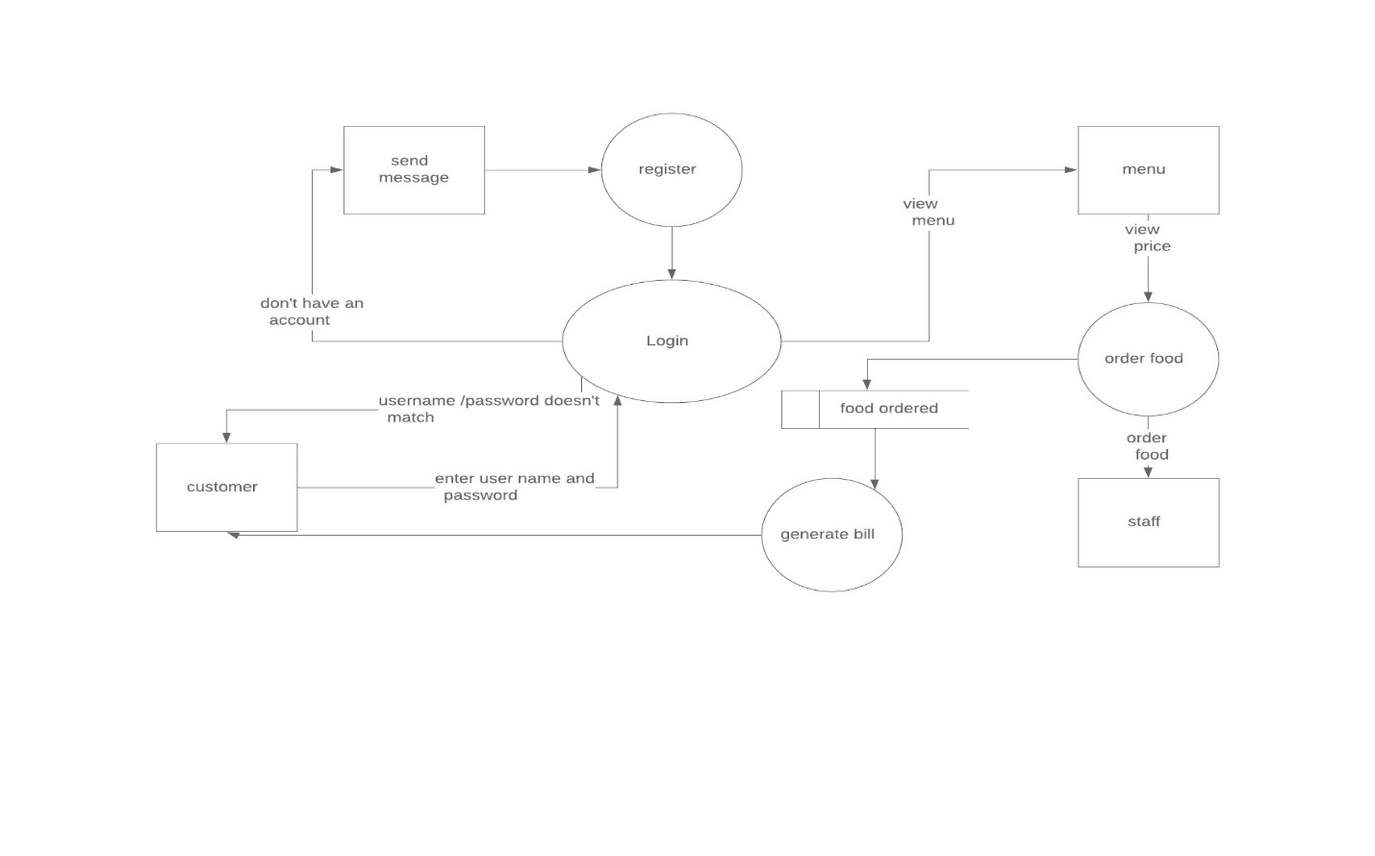

## 2.2.1 Information gathering technique:

* Interview

Interview of the users and stakeholders are important for creating a better software. Without having any information regarding the expectation and goal of the stakeholders and users, then there are chances of satiate them. While developing the software we have to understand the perspective of the people we have interview so that we can do it in proper address and weigh their inputs.

* Observation

The observation convers the study of users in it natural habitat. By watching users, a process flow, pain points, awkward steps and opportunities can be determined by an analyst for improvement. It can either be passive or active.

* Survey

Gathering information from different and many people and interview with time constraints and less budget: a questionnaire survey can be used. The survey tells users to choose between the given options like agree/disagree or sometimes rating is also available. Survey cannot we made by one person but one can add meaningful insight in it.

# 2.3 Feasibility Study

A feasibility study is an analysis that relevant factors into account that includes economic, technical, and scheduling considerations to determine the possibility of completing the project with 100 percent success rate. It is the very first design stage of a project, which brings together the elements of knowledge that indicate if a project can be made or not. Some of the sectors of feasibility study are mentioned below:

* Technical Feasibility

It is one of the most important criteria for selecting material for digitization. The physical characteristics of source material and the project goals for capturing, presenting and storing the digital surrogates dictate the technical requirements.

* Economic Feasibility

It is the most commonly used method for determining the efficiency of a new project. It is also known as cost analysis. Helps in identifying profit against investment expected from a project. The essential factors involved in this field of study are cost and time.

* Legal Feasibility

Legal feasibility is the study to know if the proposed project conform the legal and ethical requirements. There are things to consider in legal feasibility and they are privacy, nepotism and accountability. It is to ensure that the project is legally doable.

* Scheduling Feasibility

It is the process of assessing the degree to which the potential time frame and completion dates for all major activities within a project meet organizational deadlines and constraints for affecting change.

* Behavioral Feasibility

It includes how strong the reaction of staff will be towards the development of new system that involves computer’s use in their daily work. So resistant to change is identified.

# 2.4 Software Requirement specification:

Requirement Analysis is the process of defining the expectations of the user for an application that is to be built or modified. It is team effort that demands a combination of hardware, software and human factors engineering expertise as well as skills in dealing with people. It also involves all the tasks that are conducted to identify the needs of different stakeholders. The requirement analysis means to analyze, documents, validate and manage system requirements.

## 2.4.1Functional Requirements:

|  |  |  |  |  |
| --- | --- | --- | --- | --- |
| ID | Title | Description | Rational | Dependency |
| FR101 | Registration | Users can create a new account in the system with this function. | To create a new account. | N/A |
| FR102 | Login | Users can login to their account. | To login to their account. | FR101 |
| FR103 | Logout | After log in users can logout from their account. | To logout their account. | FR102 |
| FR104 | Add to stock | Admin can add the available dishes in the restaurant menu. | To let users know about the available dishes | N/A |
| FR105 | Update stock | Admin can update the available dishes in the menu. | To update the dishes on the menu. | FR104 |
| FR106 | Delete stock | Admin can delete a particular dish from the menu if it’s not available. | Delete a particular dish from the menu. | FR105 |
| FR107 | View Orders | Users can see what they have placed the orders of food items and admin can also know what orders have been made. | Makes easier to recheck the orders before confirming it. | N/A |
| FR108 | View Members | Admin can see how many people have made account. | To know about people log in and users information. | N/A |
| FR109 | Search Food items | Users can search food they want rather than going through all the menu. | To make user easier and letting them know about the food is available or not. | N/A |
| FR110 | View Food menu | Users can see the food menu of all the categories they have search of. | To see all the categories of food which available in the restaurant. | FR109 |
| FR111 | Price of the food | Users can also see how much the food is cost. | To make sure that the users knows the cost of food before they make the payment | FR110 |
| FR112 | View according to the categories of food | The menu should be according to the categories where the food is placed. | To make users clear about the food items categories. | N/A |
| FR113 | Edit profile | User sometimes makes mistake and want to change their profile so this helps them. | Being easier for the user to edit their profile anytime and anywhere. |  |
| FR114 | User review | After visiting the restaurant user makes review about the food. | Being a platform for making other users know how actually this place is. | N/A |
| FR115 | Generate Bill | When users place and pay the amount then it should be able to give a bill of their total price by sending it on mail or message | To make them know that the payment have been made. | N/A |
| FR116 | Forget Password | Users forget their password and can’t login into their account. | To recover the password they have forgotten. | N/A |

## 

## Non-functional requirements:

* Performance:

In the system, it should make a utilization of the time, deals with the strength, optimization etc. To make the software work properly performance of the system is very important.

* Security:

Arrangement of strong and high security should be provided which should be for the users. If there is not strong security they the date might be lost and problems will be arise.

* Availability:

The system should be made in such a way that it can be run in every possible platform not only a choice. The system should be available for the users when they want to use it.

* Usability

While making the software it should not only made from one perspective but make it by being a user friendly one so that the user won’t find it difficult to use it and enjoy to use.

* Recoverability

Sometime there might be some problem occurring which might be crush in the system as well as failures so they system should be able to recover it by not missing a single information. They should maintain a proper back up while the time of failures.

* Reliability:

Designing is certainly somehow important part of it but it should be made like it has been designed. If it works as it has been designed then users will be more reliable to the system.

* Supportability

While making a website it should be made as if it fits to every screen sizes of every pcs and mobile phone sizes.

## MoSCoW prioritization:

MoSCoW prioritization, also known as the MoSCoW method or MoSCoW analysis, is a popular prioritization technique for managing requirements. The method is commonly used to help key stakeholders understand the significance of initiatives in a specific release.

**MOSCOW** stands for:

**M: Must have**

**S: Should have**

**C: Could have**

**W: Won’t Have**

|  |  |  |  |
| --- | --- | --- | --- |
| FR_ID | Requirement | MoSCoW | Descriptions |
| FR(101) | Registration for customer | M | To know customers info, store customer’s data for business purpose. |
| FR(102) | Login for admin | M | Admin’s login opens admin dashboard where only admin could access through it. |
| FR(103) | Login for customer | M | Customer’s login allow access to book food items, view description of foods. |
| FR(104) | Add to stock | M | Stocks are added by admins, admin should add the all the stock available. |
| FR(105) | Update stock | M | Details of food items might get changed in some aspect like price or other specification which should be changed. |
| FR(106) | Delete stock | C | Stocks which are not more available on the stocks should be deleted or sometimes wrong information might be added. |
| FR(107) | View order | C | User could view what they have place order (User), also for (admins) they should know what the orders are so far. |
| FR(108) | View members | C | Admins could view the joined members in the restaurant website to retrieve the user’s info. |
| FR(109) | Search for Food items | M | For the customer’s they must search the dish they want to have. |
| FR(110) | View Food Menu | C | Many list of food items are available in the website so that customer view through it. |
| FR(111) | Show price of Dish | M | Prices of dish should be viewing to know how much the food costs. |
| FR(112) | View according to Categories of Food | S | Customer may view food according to categories of it. |
| FR(113) | Edit Profile | S | If some changes might be done with profile. |
| FR(114) | User Review | C | Review of user help to improve the restaurant. |
| FR(115) | Generate Bill | M | After ordering food, bills should be given. |
| FR(116) | Forget Password | C | To recover the password. |
| FR(117) | Cancel Order | M | To Cancelling booking. |
| FR(118) | Confirm Order | M | To Confirm your booking. |
| NF(R19) | Logout | M | Logout after you use the site. |

# 2.4.4 Hardware Specification

Restaurant Management system should be able to work with the given below hardware specification:

OS: Windows XP/Vista/7/8 and Linux

CPU: Pentium IIII (700MHz) and above

Memory: 128 MB and above

Capacity: Network interface card, mouse, keyboard and monitor

# 2.4.5 Software Specification

As restaurant management system is an application based on website, internet connection should be connected. The restaurant management system software should be support of MySQL as DBMS.

Use case diagram is a behavior diagram in Unified Modeling Language (UML). Use case diagrams shows the functionality of a system using actors which shows the functions of the system. They are a set of services, actions, and functions that the system has to perform. In this context, a "system" is something being developed or operated, such as a web site. The "actors" are entities operating under distinct roles inside a system.

Use case diagrams are important for picturing the functional requirements of a system that will translate into design and development priority. They also helps to identify any internal factors or external factors that may affect the system and should be taken into thought.

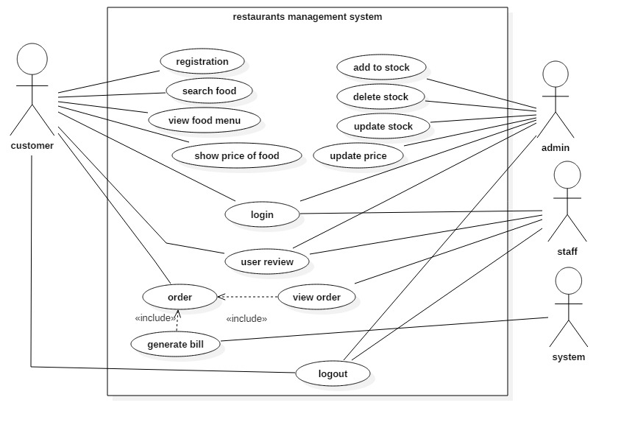

Figure Use case diagram

# 2.6 NLA (Natural Language Analysis)

Natural Language Analysis also some time referred as Natural language processing is the skill of a computer program to understand human language as it is spoken. NLA is a component of artificial intelligence. It is done for computers to process to understand natural language in order to perform tasks like language translation and question answering.

A restaurant needs a system that can manage orders of customers. The system must allow customers, staff and administrator to have an account. Customer must be able to view menu, orders done by them, price of food and also give review. Whereas staff of the restaurant must be able to take orders and view reviews given by customers. And the administrator must be able to add, delete and update stock and it information. The admin should also be able to reviews, order, menus and price of foods. The bill must generate automatically once the order is done by customers.

Separating nouns (class):

Restaurant

Orders

Menu

Order

Price of food

Review

Customers

Staff

Admin

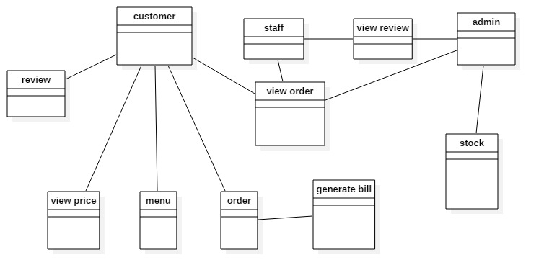

Figure Natural Language Analysis

## 3.3 System architecture:

The system architecture is a general discipline that can handle objects called system, in a way that supports perceptive about the structural assets of these objects. The system architecture is a conceptual design that helps to explain a system view, behavior and its structure. I have used a three-tier architecture for this project. Below is the diagram of three tier architecture for better understanding:

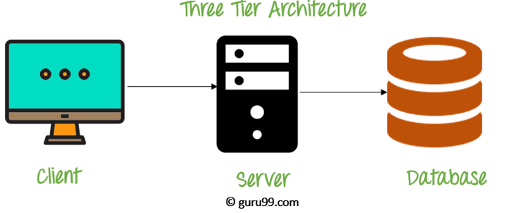

Figure 3 Three Tier Architecture

The three-tier architecture consists of three part:

* Client tier: It is the application clients that access a JAVA EE server and located on a different machine from server.
* Server tier: It is entire application which is distributed across different computing layer.
* Database tier: This is responsible for the database for functional storage, processing, and integrity of data.

# Chapter 3

# Design:

3) What is design?

Another stage in the (SDLC) software development life cycle is designing. Designing is important for a project as it assistances to confirm that all the necessary requirements, operation and also features which are decided the predecessor process.

3.1 structural modelling:

It represents the static aspect of the system. It shows those parts of diagram which forms the main structure and therefore stable. They are not utilizing time related concepts, it doesn’t show the details of dynamic behavior. It may show relationships to the behaviors of the classifiers exhibited in the structure diagrams. The structure diagram elements represent the meaningful concept of a system and may include abstract, real world and implementation concepts.

3.1.1 Final class diagram:

A static structure diagram which describes structure of a system at the level of classifiers of the system, subsystem or component, different relationships between classifiers, their attributes and operations, constraints. Notations utilized for class chart are:

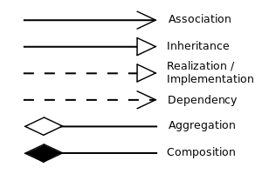

Figure Final class diagram chart

Definition:

A class diagram can be defined as the methods and variables in an object which is a specific entity in a project or the unit of code representing that entity. Which then shows the relationship and dependences between classes.

Justification:

I have used class diagram in my project because:

1. It helps to think out the structure of the classes and how they will interact with each other.
2. It provides a model for maintaining the program to get an overview of how the system is structured.
3. It is necessary for the object-oriented programming.

Diagram:

Diagram explanation:

* + 1. Data-Flow diagram:

Data flow diagram is a methodology of graphical structural analysis and information system design, which describes the sources external in respect to the system, recipients of data, logical functions, data flows and data stores that are accessed. There are some reasons for using data flow diagram and the reasons are as follow:

* It helps in logical information flow of the system.
* It can be used in determination of physical system construction requirements
* It has simplicity of notation
* It helps in establishment of manual and automated system requirements.

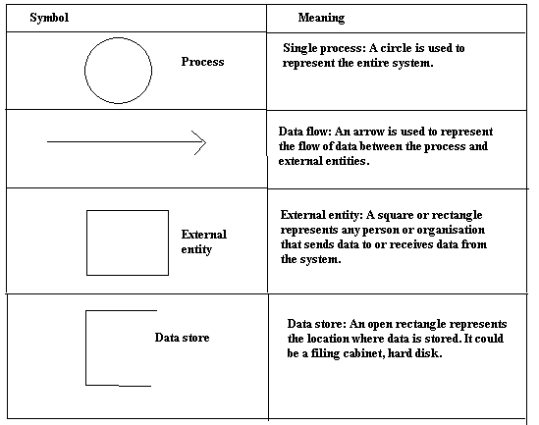

Figure Data Flow Diagram Symbol

Diagram:

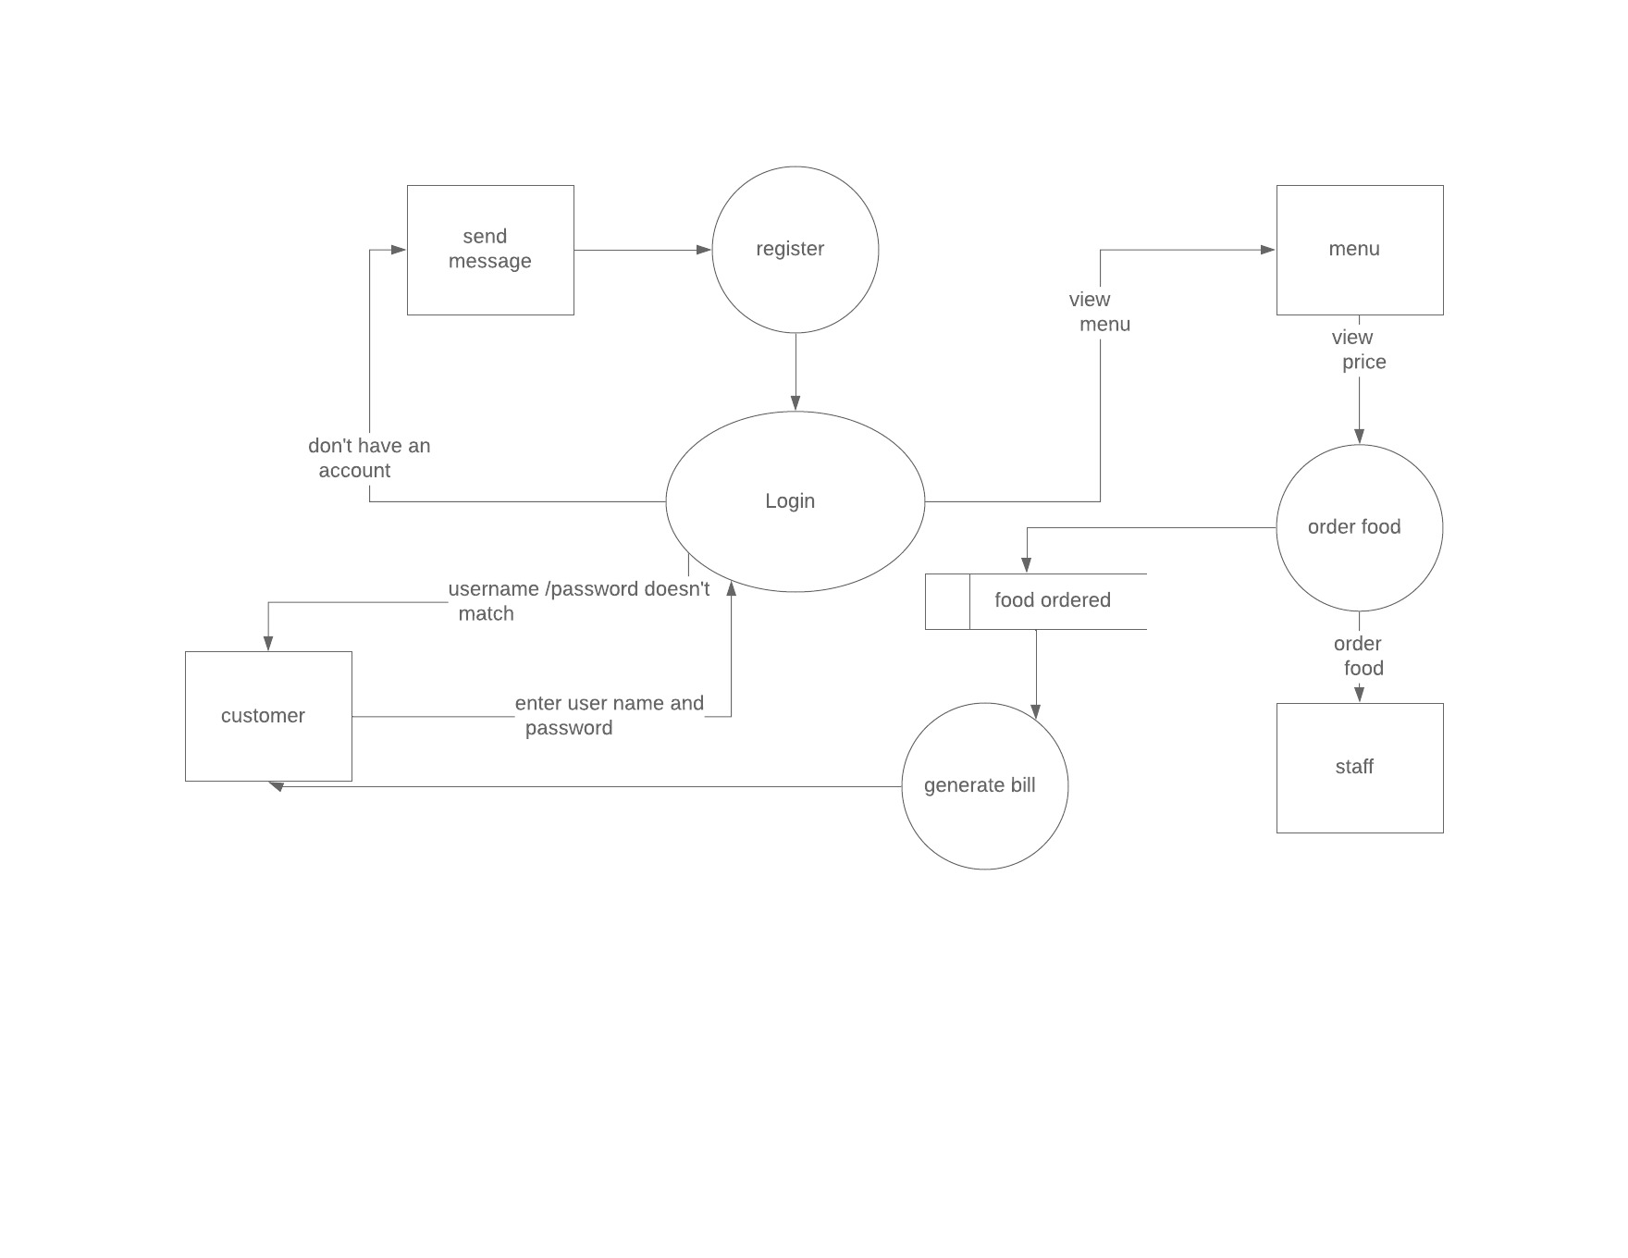

Figure 6 Data Flow Diagram

Above diagram, Restaurant Management system is web based system. Here I have drawn a data flow diagram which shows the flow of data that are done in the system. In the diagram above a customer can register an account if they don’t have an account. After logging in into the system user can view menu, price and order food. The system will automatically generate bill based other users order. Staff of the restaurant can view orders of customers and provide them food.

* 1. Behavioral modelling:

It is act of guiding the employees or any other things how to do something by showing them the standard modeled behavior. It is one of the process is of the premise that people tend to inevitably learn things they may see in the coming days or future. It encouraged to act as well as respond according to the situations about their specific roles. There are many behavioral modelling and the suitable modelling I have done in my project are listed below:

3.2.1 Activity diagram:

It is a flowchart to represent the flow from one activity to another activity and that activity can be described as an operation of the system. It captures the dynamic behavior of the system. It is used to construct the executable system by using forward and reverse engineering techniques.

While representing the diagram notation are used are given below:

|  |  |  |  |
| --- | --- | --- | --- |
| No. | Name of Notation | Notation | Description |
| 1. | Swim lane |  | It shows the activities or flow of roles or participants. |
| 2. | Initial state |  | It is used as the starting point in the workflows. |
| 3. | Final state |  | It is used as the final point where the process ends |
| 4. | Action/activity |  | Main task that takes place in a system is demonstrated in the activity. |
| 5 | Decision |  | It is used as the conditionals for different decisions in activities |
| 6. | Control Flow |  | It represent the path for flowing data |
| 7. | Send signal |  | Denotes that the signal have been sent. |
| 8. | Fork |  | Represents a flow that may be branched into two or more than two similar data flows. |

Diagram: 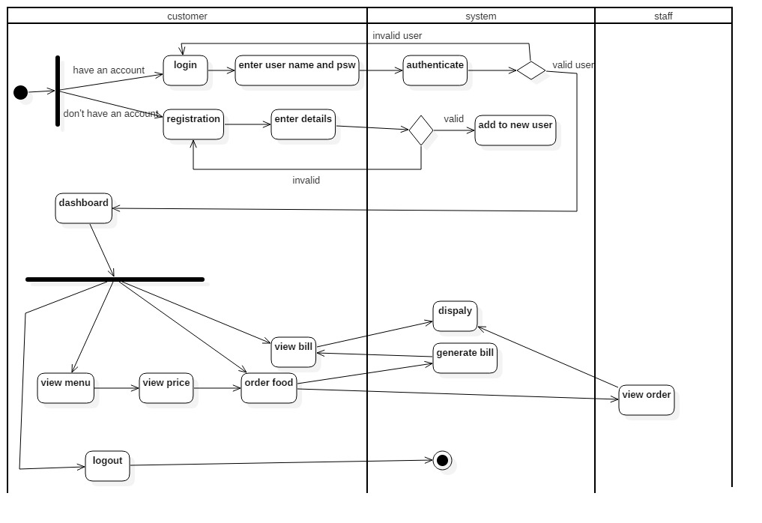

Figure 7 Activity Diagram Users

In above activity diagram, it shows that an individual should be register first to get access into the system to know all the features in the particular application. After registration a user can login into the system by giving correct information of username and password in the system. Verification in the system, login should be done first and after that access of login cane be act as verfication being authorized users. When an authorized user is accepted they are allowed to use the system if they fails then they get back in login page again. After being apporoved, they are allowed to get into the system and use the the further features and they can update their information and use the system as they want it to use. After using the system they can close the application by clicking in the log out option of the system. Once they are logged out the system they cant go back they should again go back to login page and get in the system.

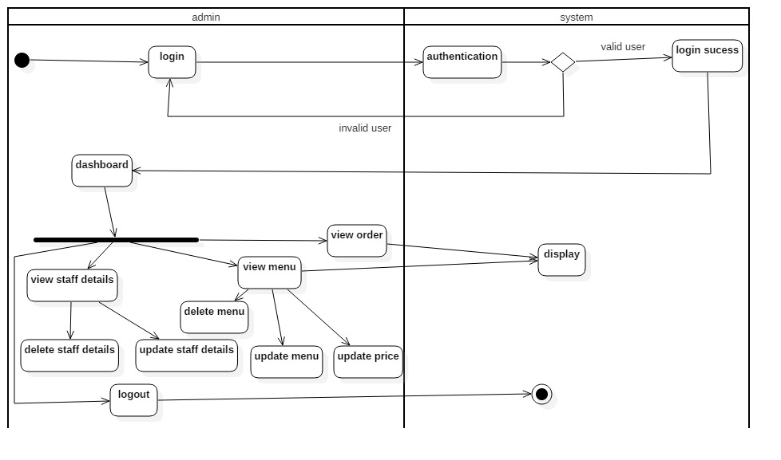

Figure 8Activity Diagram Of admin

The above activity diagram, it shows the functions done by admin in the system. Before getting into the system admin also need to get log in into the system because it is not necessary to register by being an admin. Being an admin it should be able to perform different activities in the system by adding details of users in the system. Admin cannot update and delete the data of any users which are private but can delete the account which are inactive.

* + 1. Sequence diagram:

It is interactions among classes in terms of an exchange of messaged over time. It is a good way to visualize and validate various run runtime scenarios. Sequence diagram is also known as event diagrams. This diagram helps to predict how a system will behave and discover responsibilities a class may need have in the process of modeling a new system.

Sequence Diagram is used in project in following reasons:

* It is used to show the interactions between objects in the sequential order.
* It helps in communications and shows object interact.
* It is used as requirements document to communicate requirements for a future system Implementation.

Notation used in sequence diagram:

|  |  |  |  |
| --- | --- | --- | --- |
| No. | Name of notation | Notation | Description |
| 1. | Lifeline |  | It represents the sequential events taken place in particular time |
| 2 | Message |  | Used to send and reply the messages within the objects |
| 3. | Recursive message |  | Used when the object need to send message to itself |

Diagram:

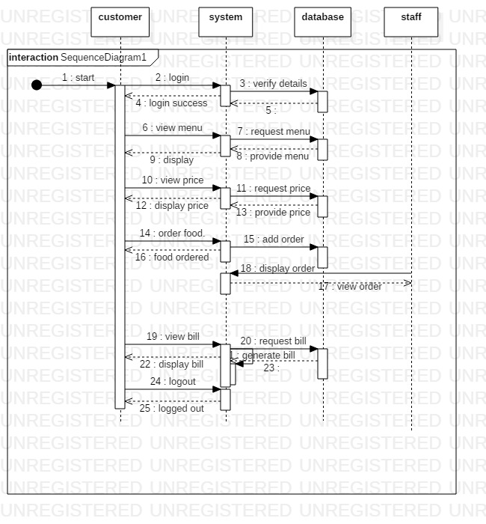

Figure 9 Sequence Diagram of Customers

The above sequence diagram of customers accepts all the participations which are reasonable between inquiries from customer side. It shows about how a customer can make communication with the structure when signing in, including, refreshing, seeing profile customer and giving message to different customers and about log out. It likewise sets up circle and if else condition in the midst of different associations.

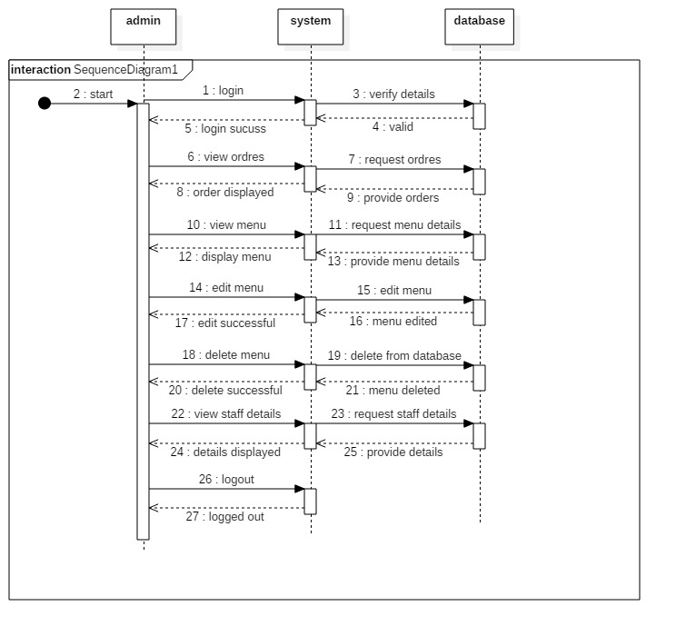

Figure 10 Sequence Diagram of admin

* 1. Database modelling:

It is a collection of processes that facilitate the designing development, implementation and maintenance of enterprise data management system.

3.3.1 Data dictionary:

It is a file or a set of files that contains a database’s metadata. Data dictionary is a collection of names, definitions and attributes about data elements that are being used or captured in a database, information system, or part of research project. It is a crucial component of any relational database. Only database administrators interact with the data dictionary.

Data Dictionary is useful due to following reasons:

* Assist in avoiding data inconsistencies across a project
* Help define conventions that are to be used across a project
* Provide consistency in the collection and use of data across multiple members of a research team
* Make data easier to analyze
* Enforce the use of Data Standards

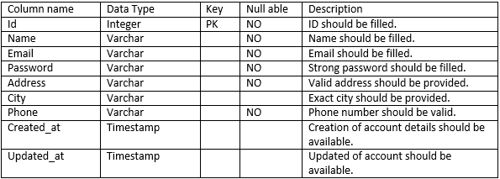

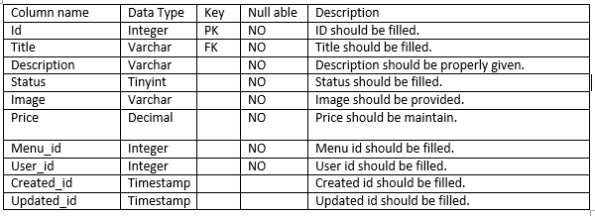

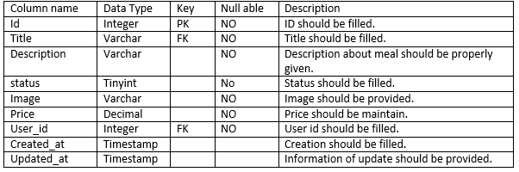

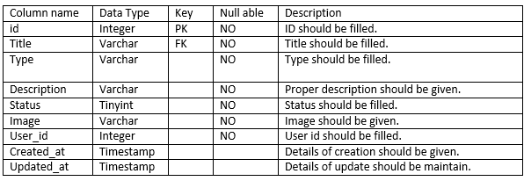

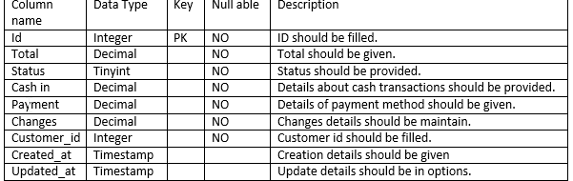

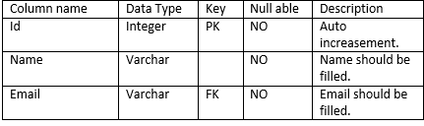

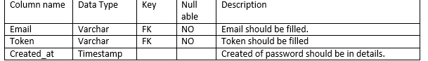

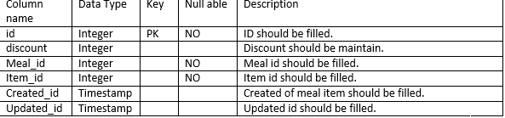

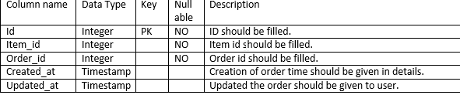

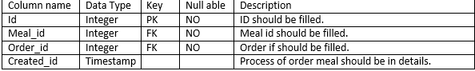

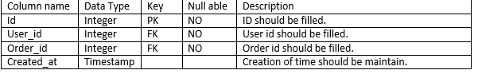

* + 1. ER diagram:

Entity diagram is a type of flowchart that illustrates how “entities” such as people, objects or concepts relate to each other within a system. They mirror grammatical structure, with entities as nouns and relationships as verbs. An entity is a real-world item or concept that exists on its own. Entities are equivalent to database tables in a relational database, with each row of the table representing an instance of that entity.

Entity Diagram is useful due to following reasons:

* It is used in database design.
* It is used to analyze database troubleshooting.
* It helps in business information system.
* It helps is business process re-engineering.
* It can be used to do research.

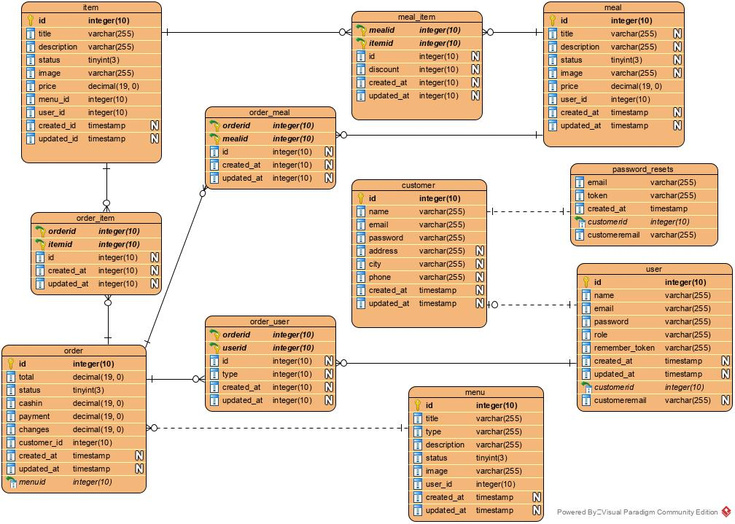

Figure 11 Entity Relationship

Above Entity Diagram shows the relationship of entity among the tables and entities where eleven table is created as item, order item, order, order meal, order user, meal item, customer, menu, meal, password resets, user.

* 1. UI modelling:

User Interface Design is the discipline of designing software interfaces for devices, ideally with a focus on maximizing efficiency, responsiveness and aesthetics to foster a good user experience. Designers aim to create designs users will find easy to use and pleasurable. UI design typically refers to graphical user interfaces but also includes others, such as voice-controlled ones. The interface should allow a user to perform any required tasks to complete the function of the product or service.

3.4.1 Prototype:

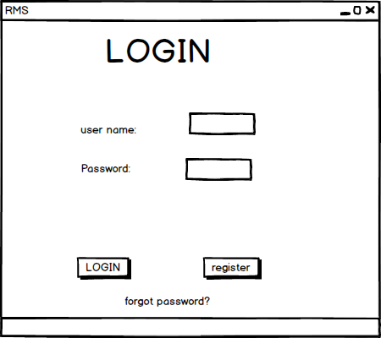

Figure 12 Login Page

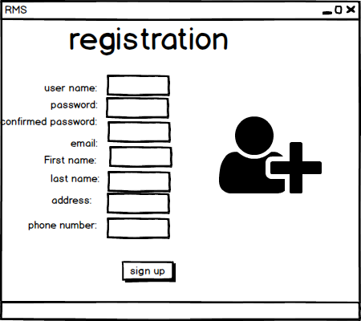

Figure 13 Registration Page

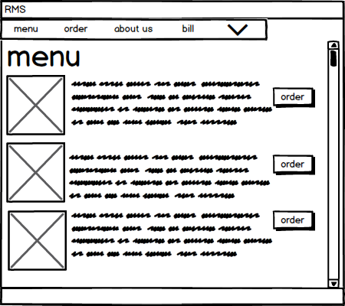

Figure 14 Menu Page

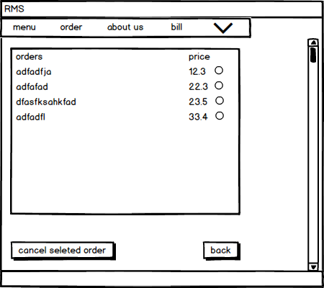

Figure 15 Order Page

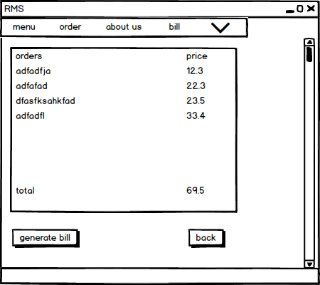

Figure 16 Generate Bill

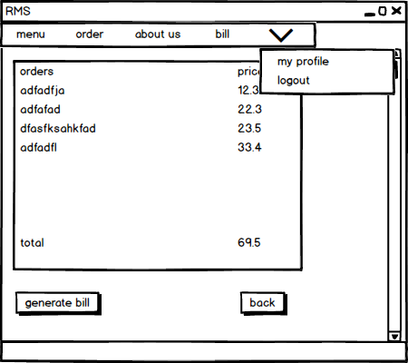

Figure 17 profile and Log out Option

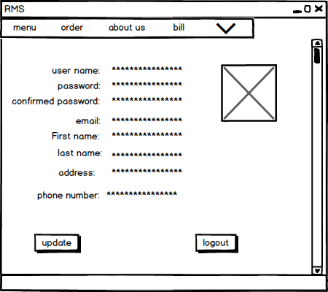

Figure 18User Profile

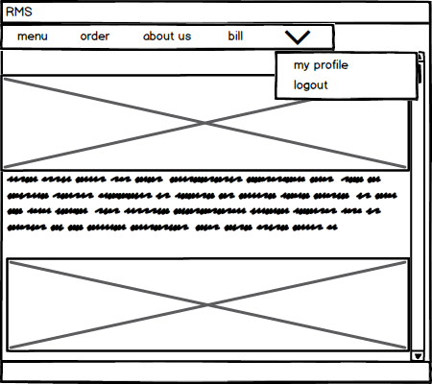

Figure 19Front Page

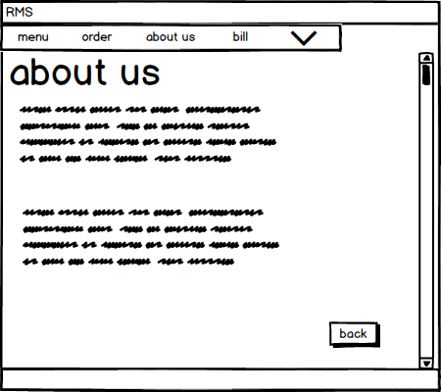

Figure 20 About us

# Chapter 5: Testing

Testing is another important step in software development. It is a process of executing a feature in program or application one by one with the aim of finding bugs. In other word, Testing can also be stated as the process of validating and verifying that the software or application meets the consumers requirements and works as expected. Testing is important so that the bugs in the application can be detected. This will help the developer fix the bugs before delivering the application to the customer. Here, in this project I have done two basic testing Black Box testing and Unit testing.

## Black Box testing:

Black Box testing aka behavioral testing, is a software testing method in which the internal structure or design or implementation of the item is being tested. The test can be functional or non-functional. This test is called black box testing because the one who is testing the application or software will not focus on the process but rather just incorrect or missing functions, interface errors, errors in external database access etc. below I have done the black box testing of my application (Restaurant Management System):

## Black Box testing:

|  |  |  |  |  |  |
| --- | --- | --- | --- | --- | --- |
| Test ID | Test Components | Action | Excepted Result | Actual Result | Remark (pass/Fail) |
| BT-01 | User registration | First name, last name, email, password, address, contact number.  (All the field were not filled so the user will not be register.) | Message: Please fill out this filed. | Message: Please fill out this field. (Some fields were not filled so the user was not registered.) | Passed. |
| BT-02 | User registration | All the fields were filled and the fields were correctly. | Message: user registered successfully. | Message: User registered successfully. (new user was added to the data base) | Passed. |
| BT-03 | User registration | The email that already exits was entered while registration. | Message: The email already exits. | Message: the email already exits. | Passed. |

Test name: user registration.

**No table of figures entries found.No table of figures entries found.No table of figures entries found.**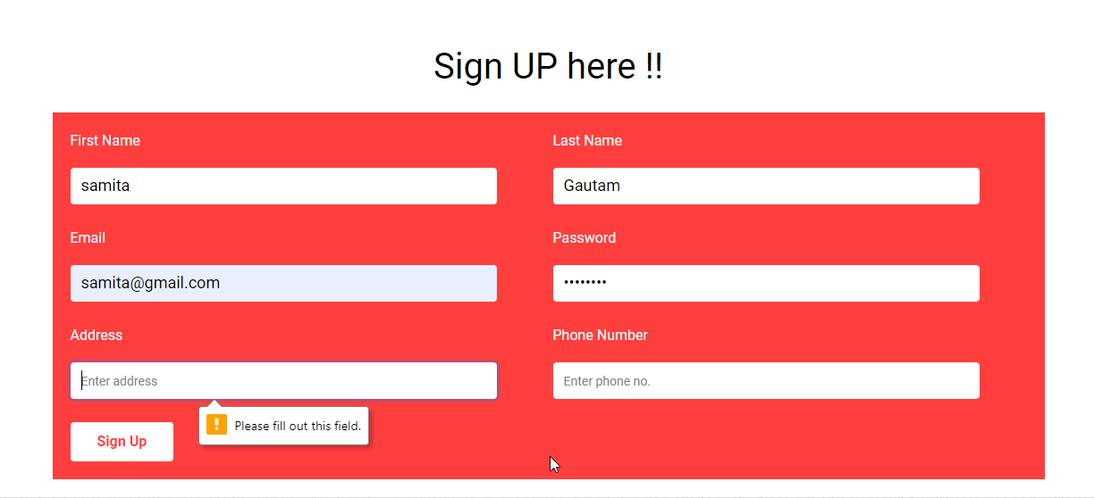

Figure testing-sign up

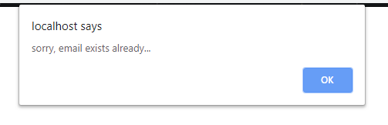

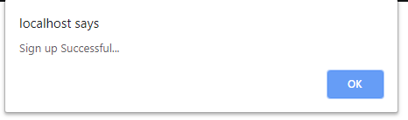



Test name: user login

|  |  |  |  |  |  |
| --- | --- | --- | --- | --- | --- |
| Test ID | Test Components | Action | Excepted Result | Actual Result | Remark (pass/Fail) |
| BT-04 | User login | Email/password was not filled. | Message: please fill out the field. | Message: Please fill out the field. | Passed. |
| BT-05 | User login | Email that is not in the database is filled. | Message: Sorry, the email does not exist. | Message: Sorry, the email does not exist. | Passed. |
| BT-06 | User login | Wrong Password is entered. | Message: email/password doesn’t match. | Message: email/password doesn’t match. | Passed. |
| BT-07 | User login | All the field is entered correctly. | User dashboard opens | User dashboard opens | Passed. |

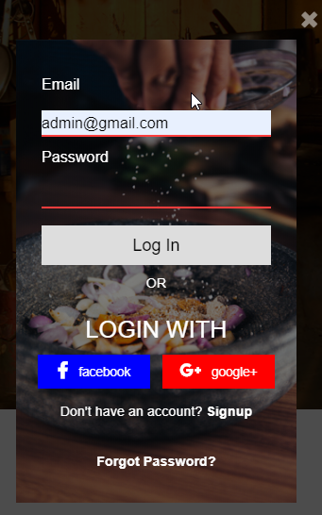

Figure testing- log in

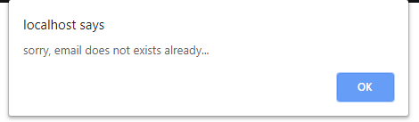

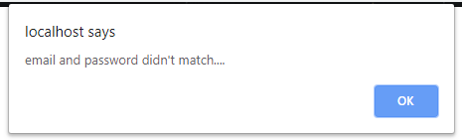

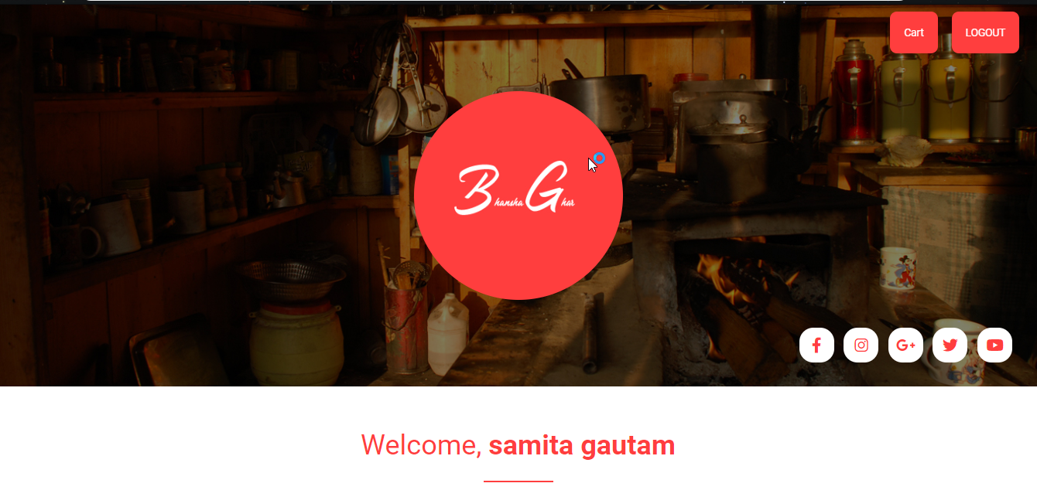

Figure testing- dashboard

Test name: show/delete/update items

|  |  |  |  |  |  |
| --- | --- | --- | --- | --- | --- |
| Test ID | Test Components | Action | Excepted Result | Actual Result | Remark (pass/Fail) |
| BT-08 | Show items | Click on menu | Shows the list of menus along with their price | Shows the list of menus along with their price | Passed. |

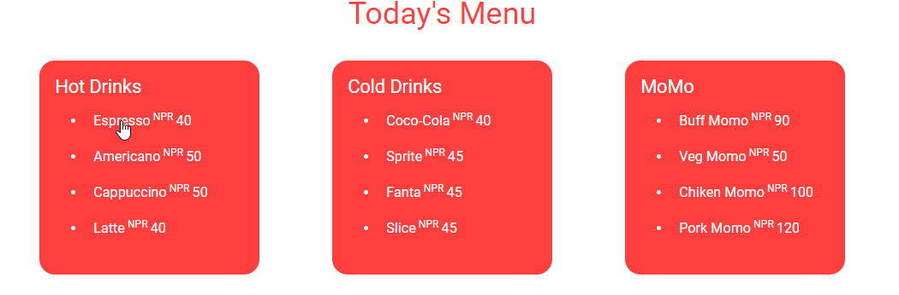

Figure testing- view

Test name: order food.

|  |  |  |  |  |  |
| --- | --- | --- | --- | --- | --- |
| Test ID | Test Components | Action | Excepted Result | Actual Result | Remark (pass/Fail) |
| BT-09 | Order food. | Click on food that you want to order. | Shows the food description along with price and quantity. | Shows the food description along with price and quantity. | Passed. |
| BT-10 | Add to cart. | Click on Add to cart. | Message: Item added successfully to your cart. | Message: Item added successfully to your cart | Passed. |
| BT-11 | Generate bill. | Add to cart. | Bill is generated with all the food ordered. | Message: Item added successfully to your cart. | Passed. |
| BT-12 | Reset cart. | Click on reset cart. | The order is reset for new order. (before the bill is generated) | The order is reset for new order. | Passed. |

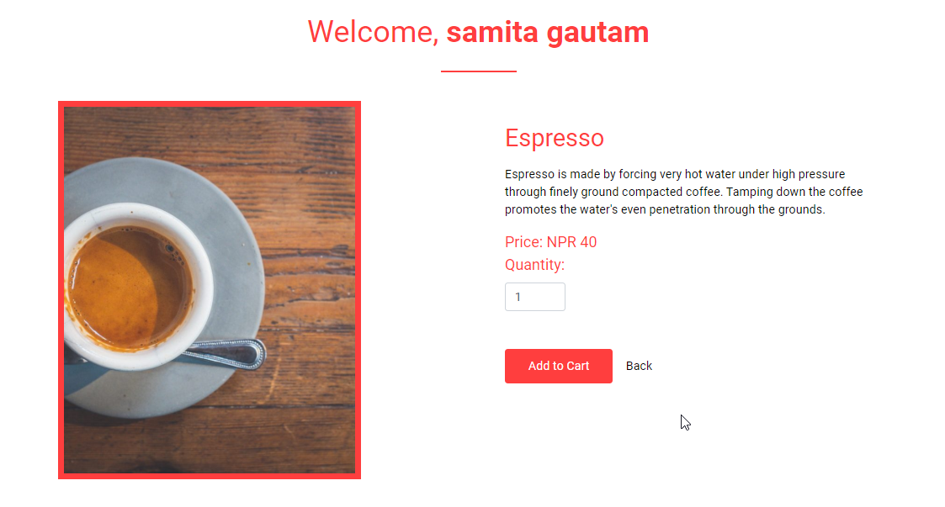

Figure testing-food ordering

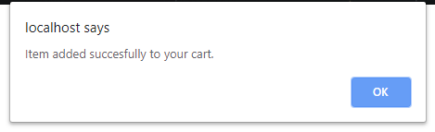

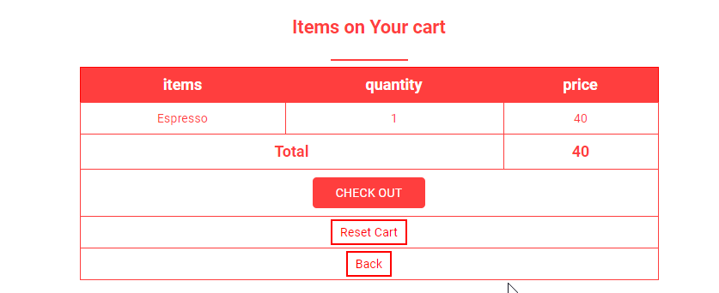

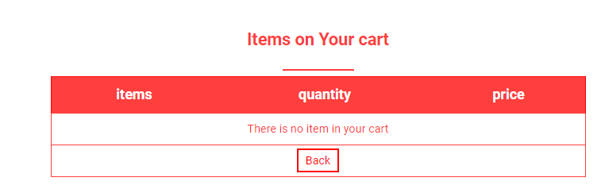

Test name: delete/edit/view items. (Admin)

|  |  |  |  |  |  |
| --- | --- | --- | --- | --- | --- |
| Test ID | Test Components | Action | Excepted Result | Actual Result | Remark (pass/Fail) |
| BT-13 | Delete items(admin) | Click on delete item. (only Admin can delete items from the menu.) | The item has been deleted form the menu(database). | The item has been deleted from the menu. | Passed. |
| BT-14 | Edit menu(admin) | Click on edit menu (Only Admin can edit menu.) | The name/price has been changed | The name/price has been changed. | Passed. |
| BT-15 | Delete user | Click on delete user. | The user account will be deleted. | The user account is deleted. | Passed. |
| BT-16 | Users order. | Click order. | Shows the list order of the users | Shows the list order of the users. | Passed. |

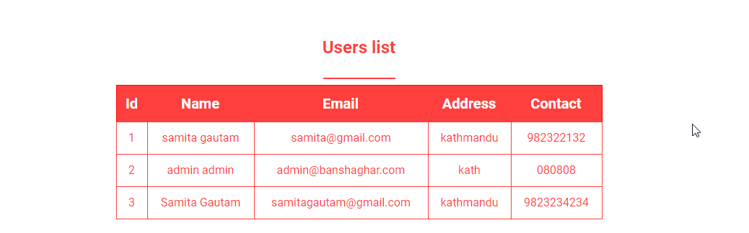

Figure testing-user list (admin)

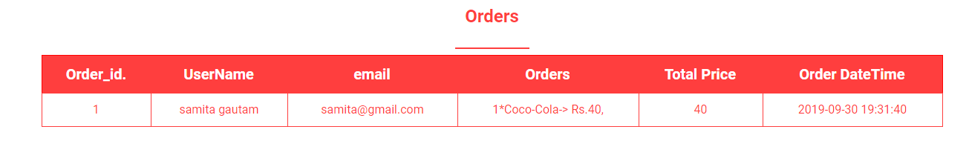

Test name: admin login

|  |  |  |  |  |  |
| --- | --- | --- | --- | --- | --- |
| Test ID | Test Components | Action | Excepted Result | Actual Result | Remark (pass/Fail) |
| BT-17 | Admin Login | Enter in incorrect admin email and password. | Message: This is not an admin account. | Message: this is not an admin account | Passed. |
| BT-18 | Admin Login | Enter correct admin email and password. | Shows the admin dashboard. | Shows the admin dashboard. | Passed. |

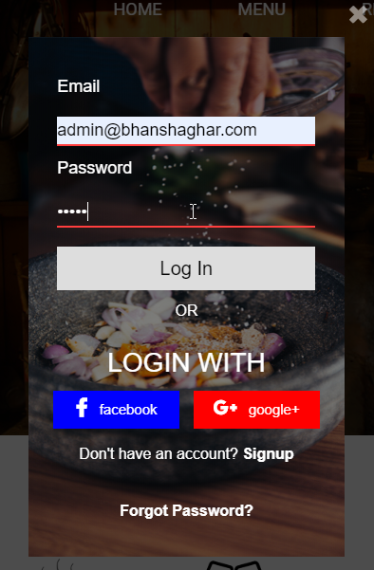

Test name: edit profile.

|  |  |  |  |  |  |
| --- | --- | --- | --- | --- | --- |
| Test ID | Test Components | Action | Excepted Result | Actual Result | Remark (pass/Fail) |
| BT-19 | Edit profile. | click on edit profile. can change username, password, email and other personal details. | Personal account will be edited. | Personal account is edited. | Passed. |

Test name: log out

|  |  |  |  |  |  |
| --- | --- | --- | --- | --- | --- |
| Test ID | Test Components | Action | Excepted Result | Actual Result | Remark (pass/Fail) |
| BT-20 | Logout | Click on Logout | User/admin is logged out of account. | User/admin is logged out of account. | Passed. |

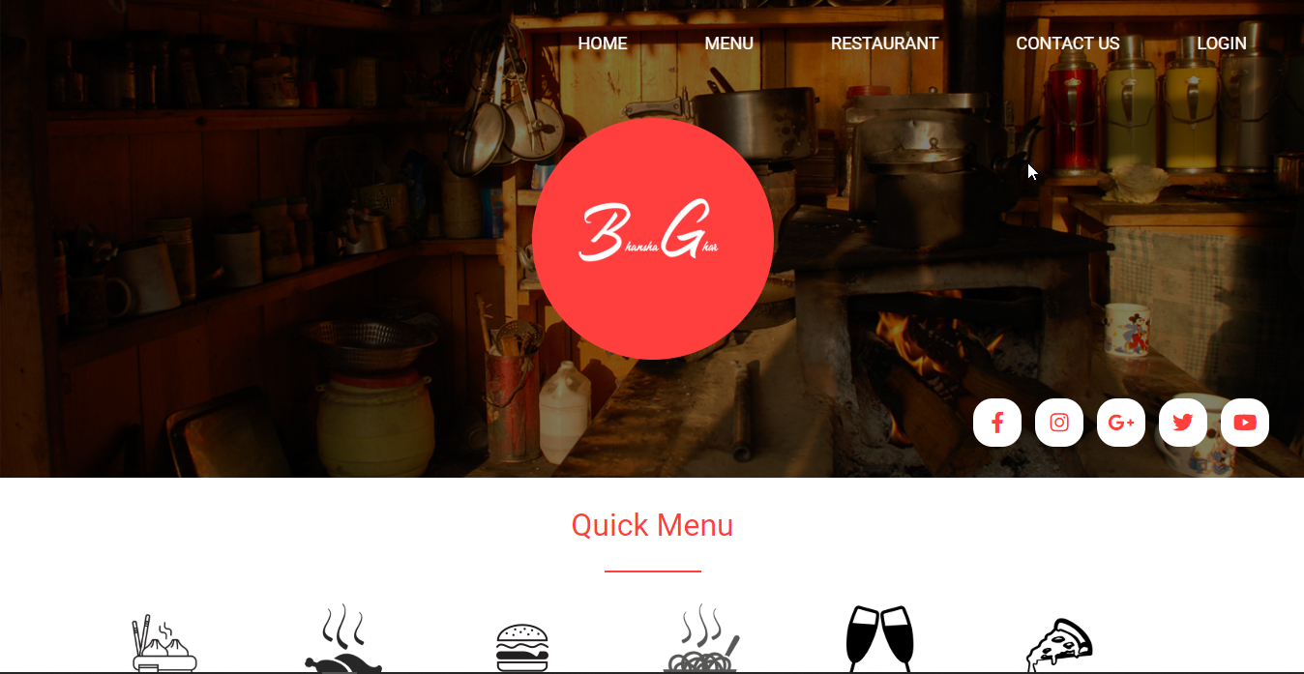

# Chapter 6

# Future Work

The future work of project are given below:

* Online payment:

The restaurant management system should be able to give facility of paying online. When there is online ordering system the online payment facility should also be provided to the customer.

* User feedback:

There is a lack of user feedback in the system. When the user feedback is involved in the system then the customers can provide information regarding to the restaurant. They can say how they feel and what things they want us to change and improve in it.

* Table reservation system:

It is important part of experience of dine-in experience. Table should be reserved via website, it reduce time and helps to manage all the table reservation from the restaurant management system. Giving a loyal customers a special experience when they come to restaurant.

* Order management(Online, Offline and third party):

Managing order from multiple sources which can become a very challenging job. Customers will be lost after being shuttling in multiple tabs and interfaces which will be a nightmare. If the restaurant management system is a good one then it will be able to manage a high volume of orders from different sources, by allowing all the incoming data into easy form of operable interface.

# Risk management:

Risk is part of all our lives. Risk management is the process of understanding, analyzing and addressing risk to make sure to achieve their objectives. It is managed proactively, optimizing success by minimizing threats and maximizing opportunities. Risk is defined at two level for the project, program and portfolios. Risk management must be closely aligned to schedule management. Cost, time and resource estimates should take risks into account.

**Impact = Likelihood * Consequences.**

Risk likelihood values:

|  |  |
| --- | --- |
| Likelihood | Values |
| Low | 1 |
| Medium | 2 |
| High | 3 |

Table 2 risk likelihood values.

risk consequences values:

|  |  |
| --- | --- |
| Consequences | Values |
| Very low | 1 |
| Low | 2 |
| Medium | 3 |
| High | 4 |
| Very high | 5 |

Table 3 risk consequences values

|  |  |  |  |  |  |
| --- | --- | --- | --- | --- | --- |
| S.N. | Risk | Likelihood | Consequences | Impact | Action |
| 1 | Limited time and financial | 2 | 5 | 10 | Should properly estimate the time and financial by making plan consulting with the organization. |
| 2 | Lack of training knowledge | 2 | 4 | 8 | Training should be provided to the developer to handle problems. |
| 3 | Malware/virus | 2 | 5 | 10 | Anti -virus software should be installed. |
| 4 | Project out of track | 1 | 4 | 4 | Analysis should be done properly. |
| 5 | User Requirement Not reach | 1 | 5 | 5 | User requirement analysis should be done. |
| 6 | Crash of Hardware | 2 | 4 | 8 | Back up should be done. |

Table 4 risk management

# User Manual:

It is traditionally a book containing large details information on various aspects of programs which includes processes and major features. It provides guidance to the user how to use the system if it’s the first time visit to the website. Not only in the case of website in products also there are given user manual for people when they buy the new product package. It gives information regarding the product how to use and what features are included inside the product. The user manual for Restaurant Management system is given below:



1. The URL is required first to visit the website.
2. If you don’t have an account then you can go the sign up bottom then you can register it.
3. Valid name, emails as well as password with phone number and address should be enter.
4. Click on the sign up after filling it up.
5. The system will pop up a message successful registration if every information provided is valid.

4



1. After registration you can go to login page.
2. After going to login page you can enter the email and password you have done while signing up.
3. After log in successfully you will enter the home page.

# Configuration management:

Configuration management is set of characteristics which is important foundation that define a final product or deliverable. It is a governance and system engineering which includes all functional and physical specifications. The configuration management process seeks to identify and track individual configuration items (CIs), documenting functional capabilities and interdependencies. It is also an automated method for maintaining computer system and software which is called consistent state.

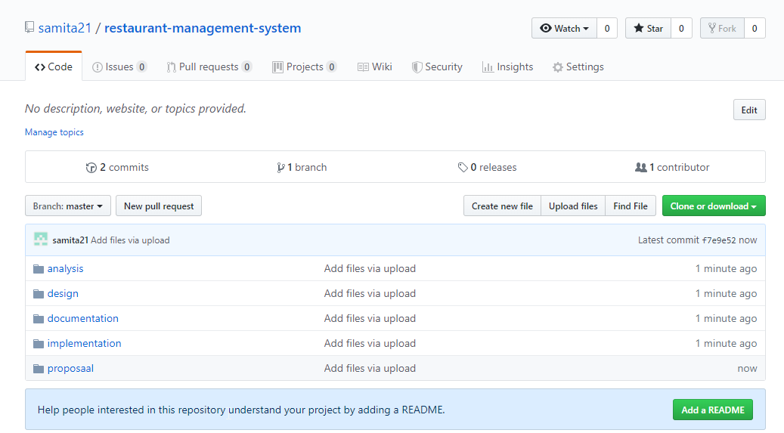

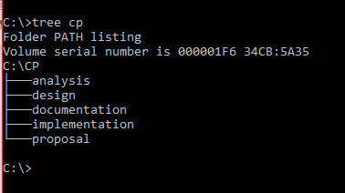

# User Interface

Home page Of Restaurant Management System

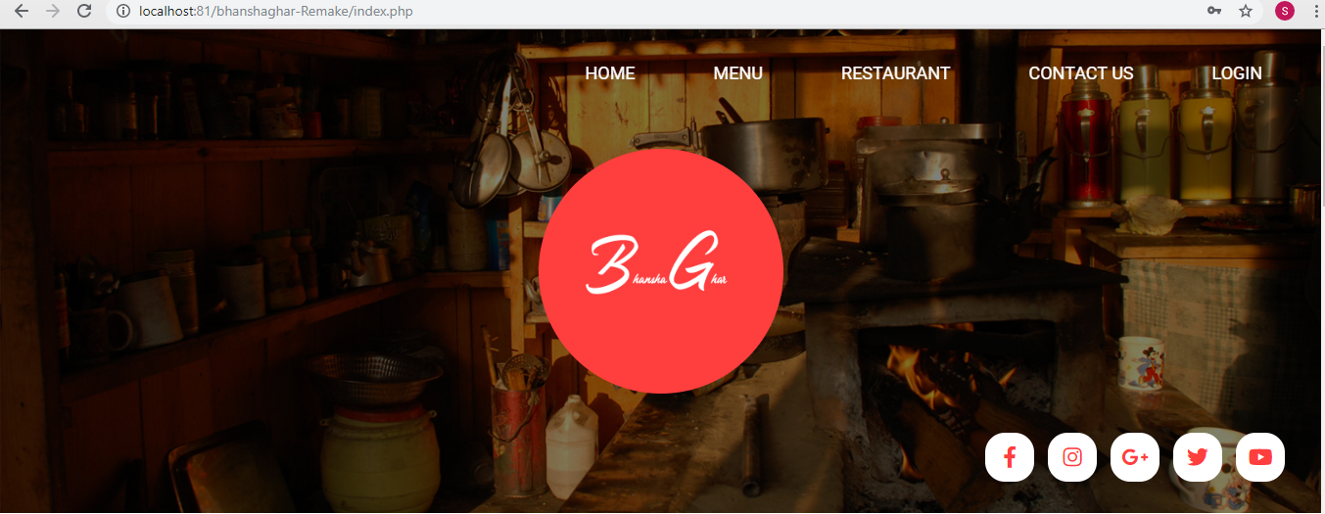

Figure 12Home page

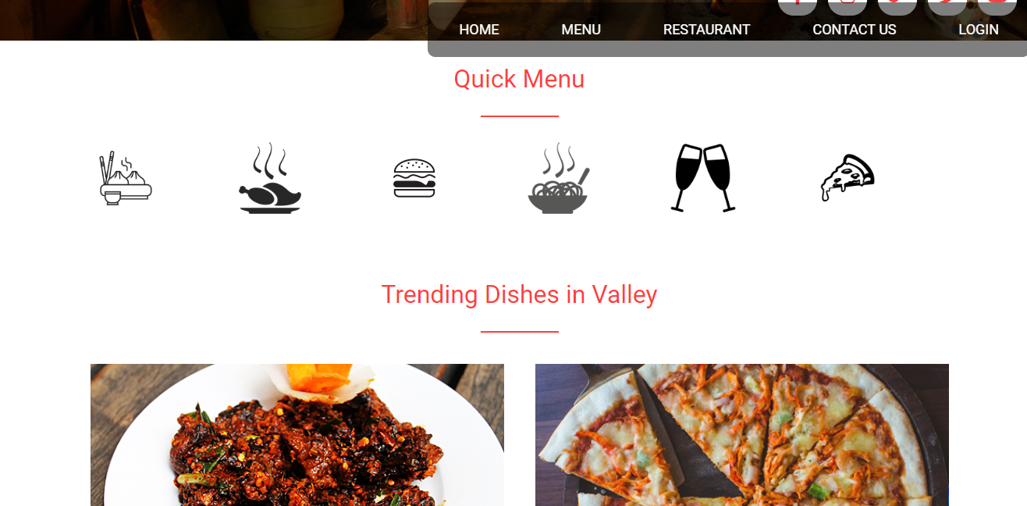

Figure 13 Home page 2

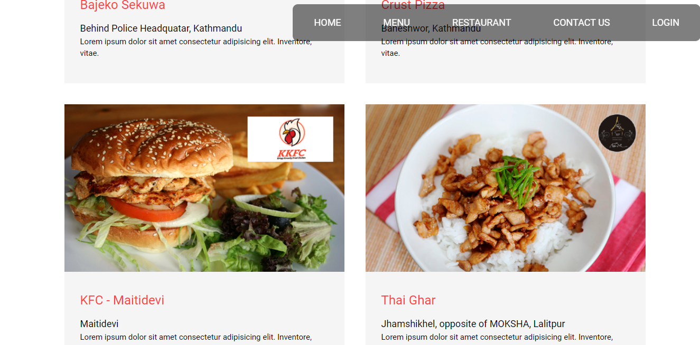

Figure 14 Home page 3

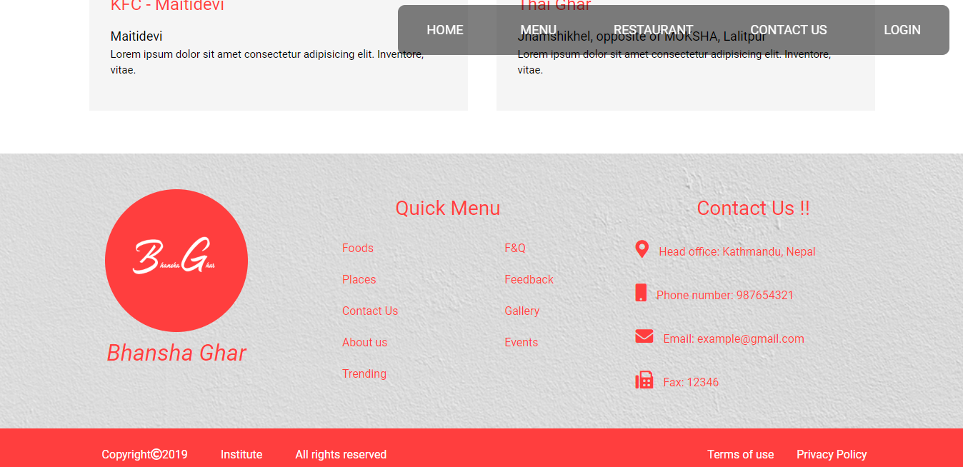

Figure 15 Home page 4

To get into the website customer need to fill up a sign up form

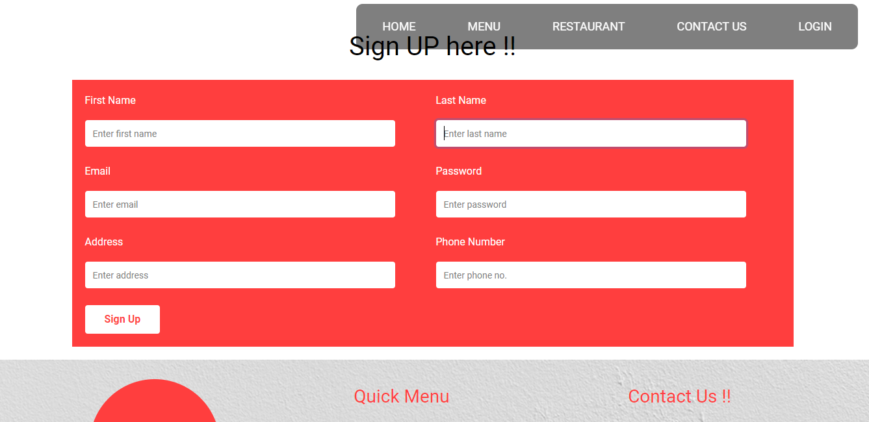

Figure 16 Sign Up form

After signing in customer need to login with the email and password

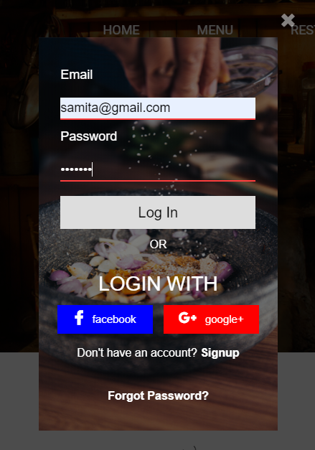

Figure 17 Login page

After login customer can get through the website

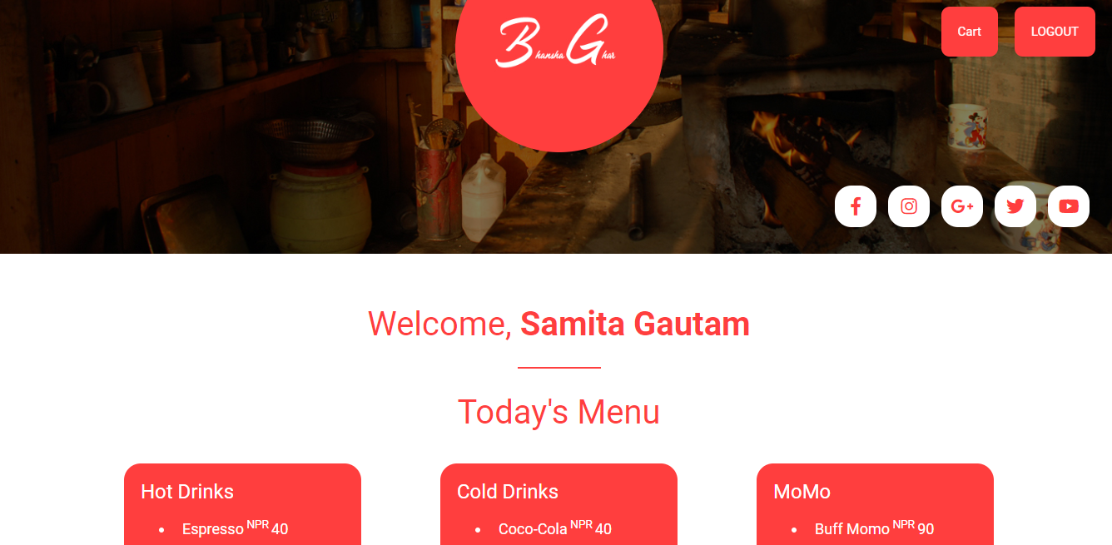

Figure 18 after login customer home page

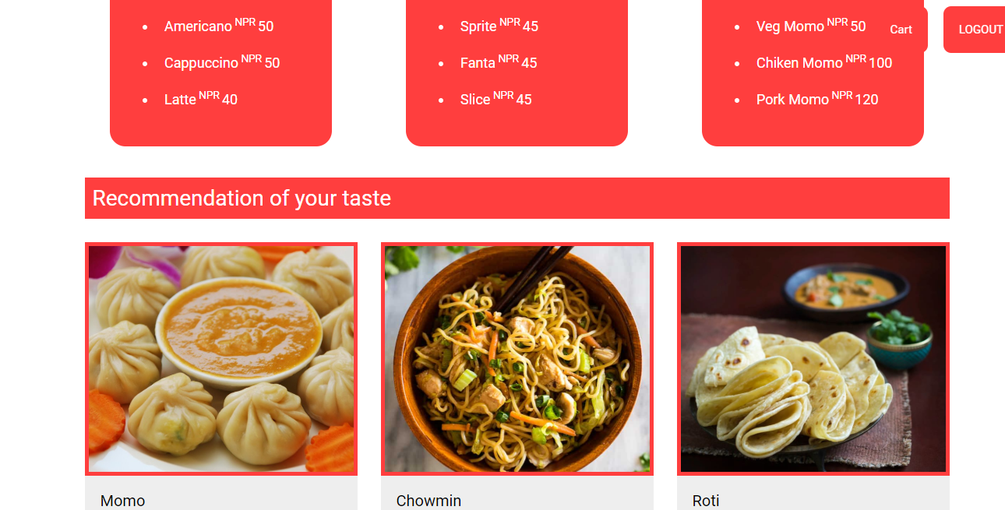

Figure 19 Home page of customer after login

After seeing the menu the customer can click on the items and cart in for further process

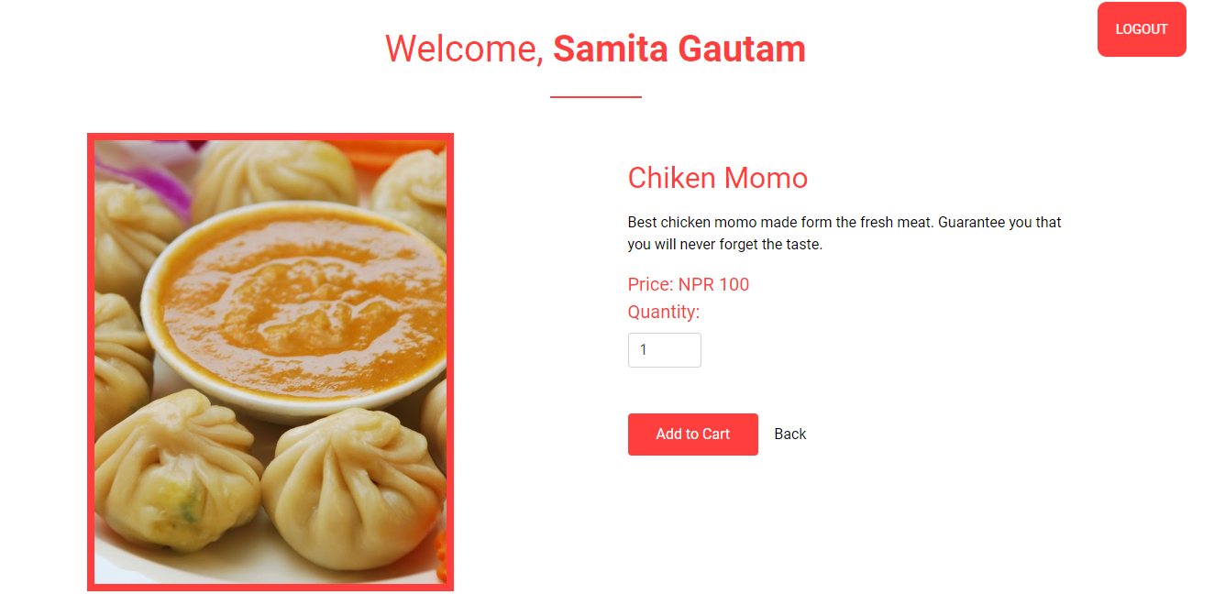

Figure 20 Item add in customer cart

After adding item to cart this message will pop up on

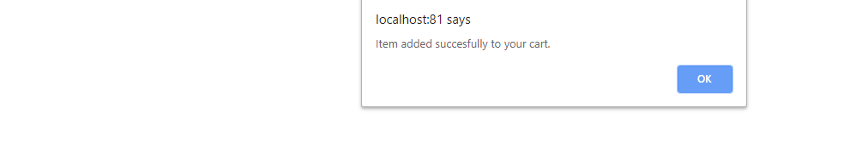

Figure 21 Message pop up for adding item successfully on cart

When the message is pop up the next thing the customer will see their total if they want to replace their order then can reset it and again confirm their final item and check out

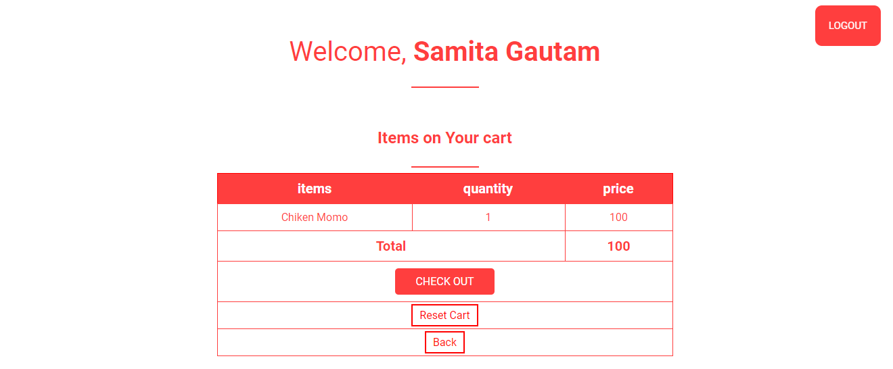

Figure 22 Item confirmation

After the item confirmation again a message will be given to customer to inform them that their order has been placed

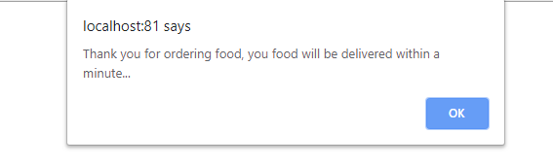

Figure 23 Order placed

Admin Login

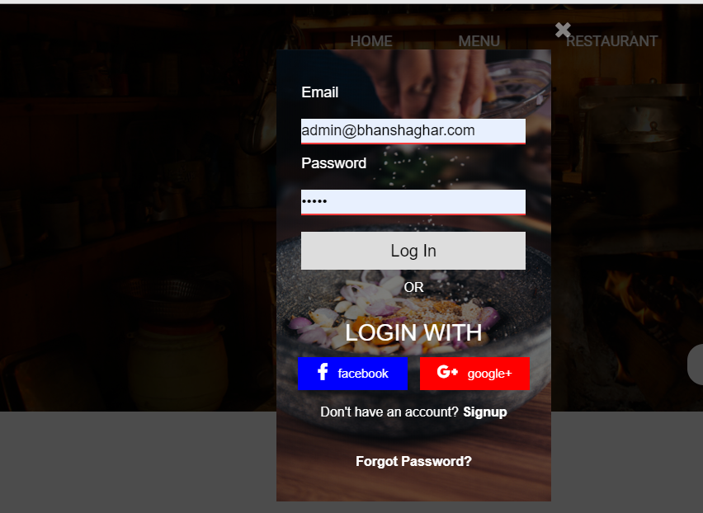

Figure 24 Admin login

When admin login to the website, then the user sign up list will be shown

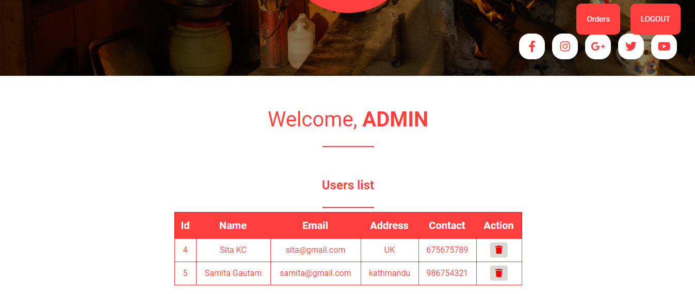

Figure 25 User list on admin page

After that admin can click on the order button to see the orders which has been placed by customers

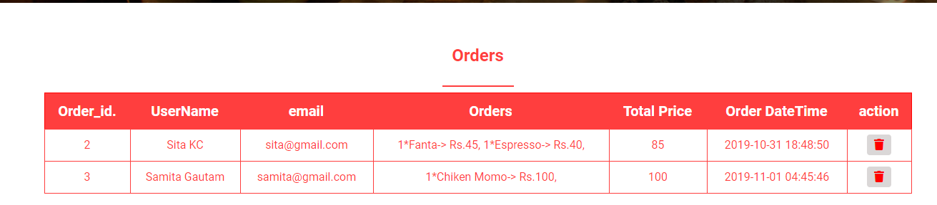

Figure 26 Order list on admin site

After he sees the order and when food is delivered he can delete the order.

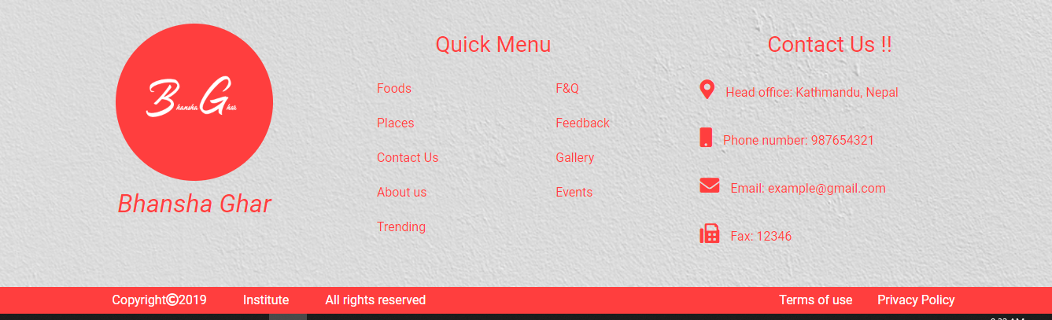

Figure 27 End of the home page

# Appendix

Admin.php code

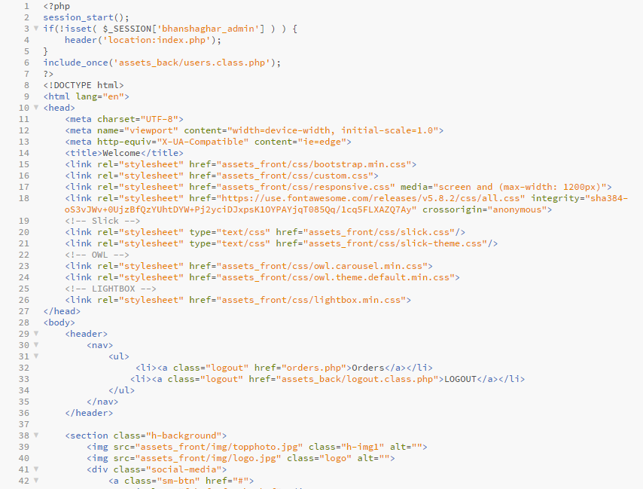

Figure 28 Admin code 1

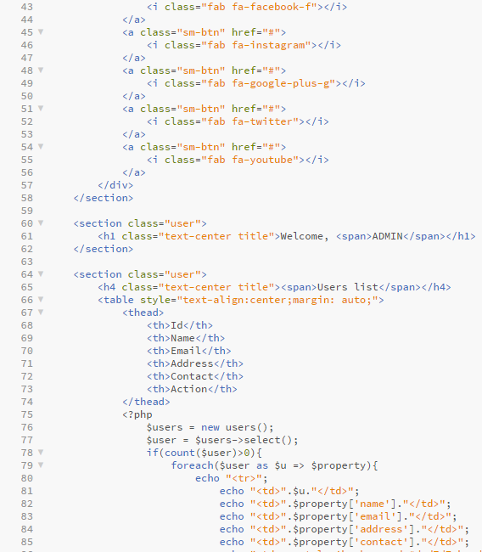

Figure 29 Admin code 2

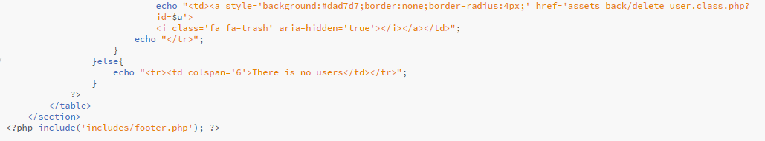

Figure 30 Admin code 3

Cart

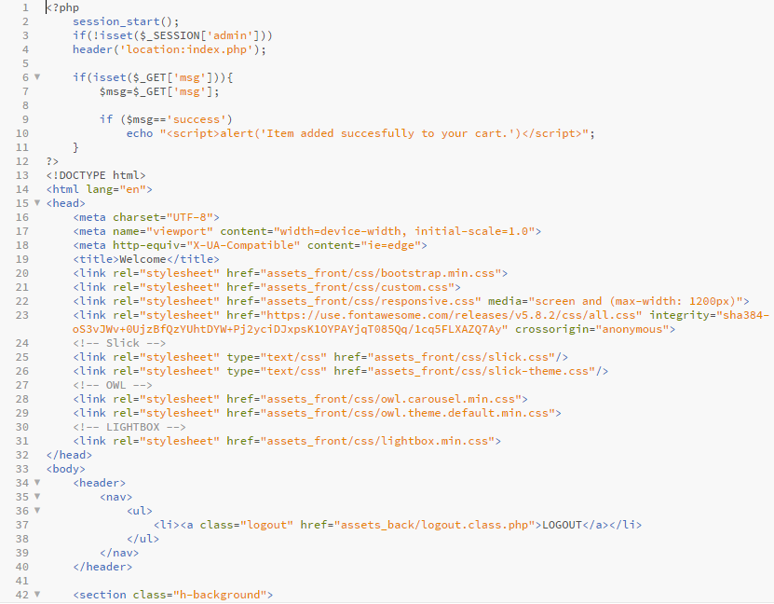

Figure 31 Cart Coding

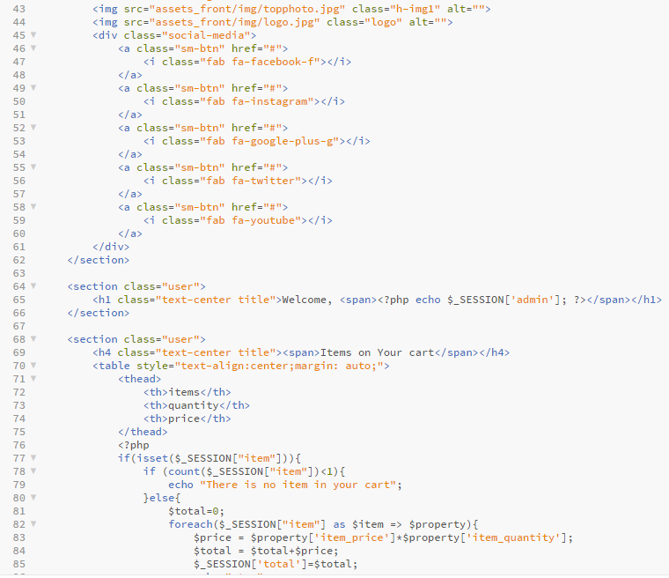

Figure 32 Cart coding 2

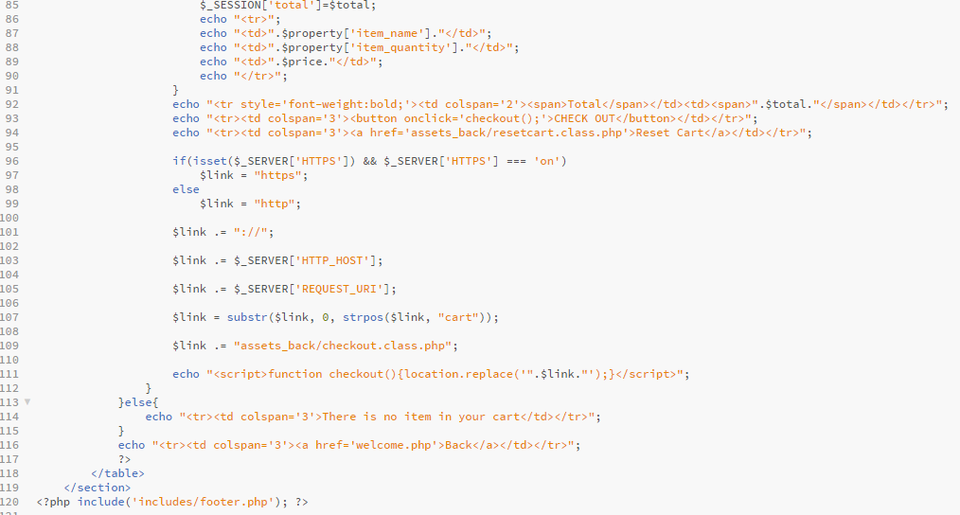

Figure 33 Cart Coding 3

Food

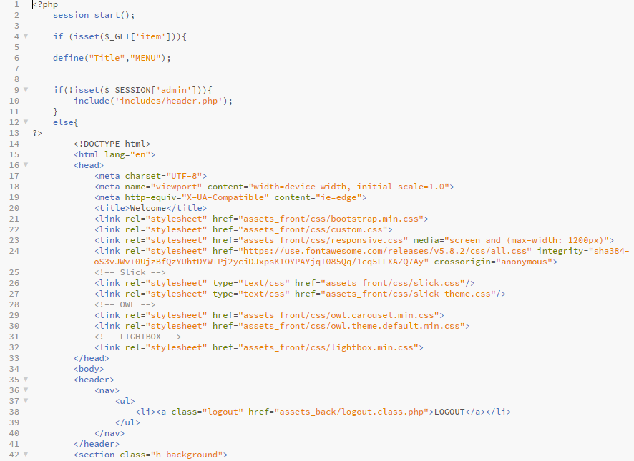

Figure 34 Food coding

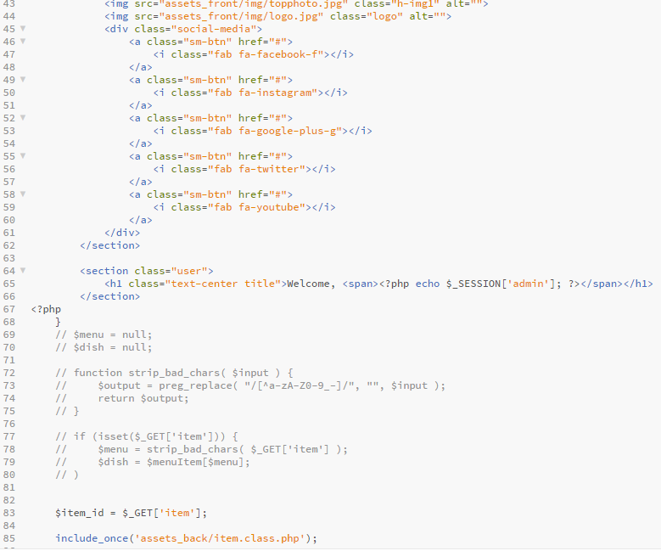

Figure 35 Food coding 2

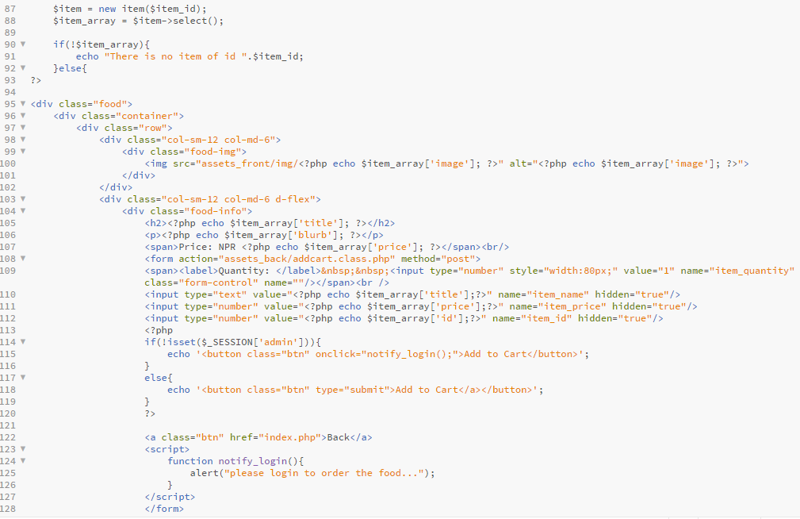

Figure 36 Food coding 3

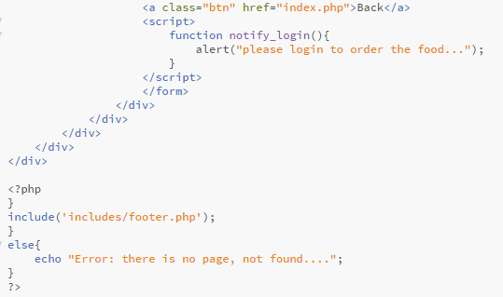

Figure 37 Food coding 4

Index

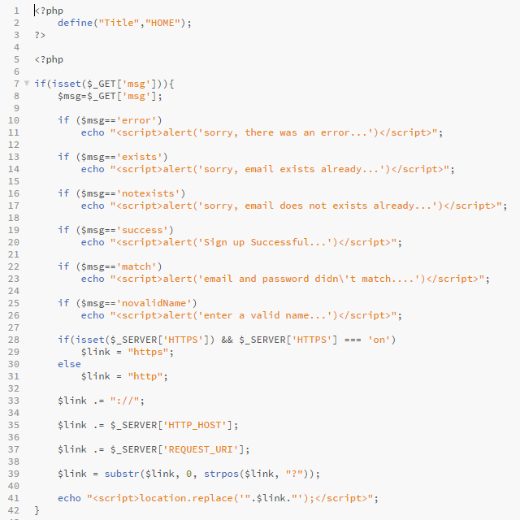

Figure 38 Index code

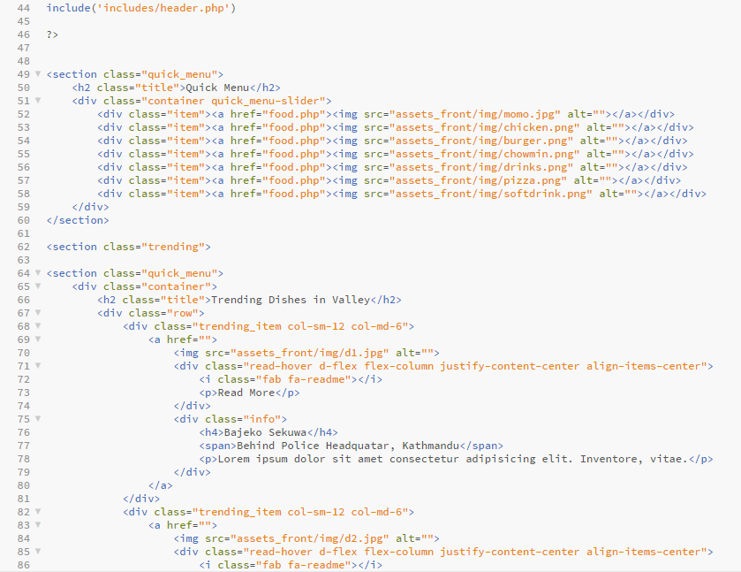

Figure 39 Index code 2

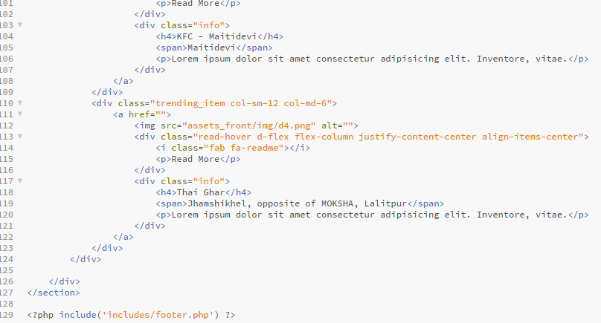

Figure 40 Index code 3

Menu

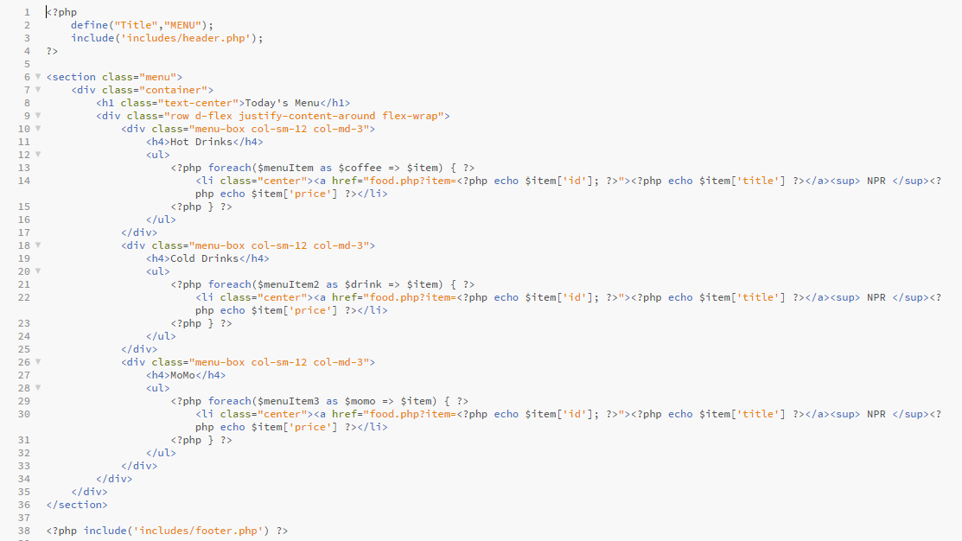

Figure 41 Menu coding

Order

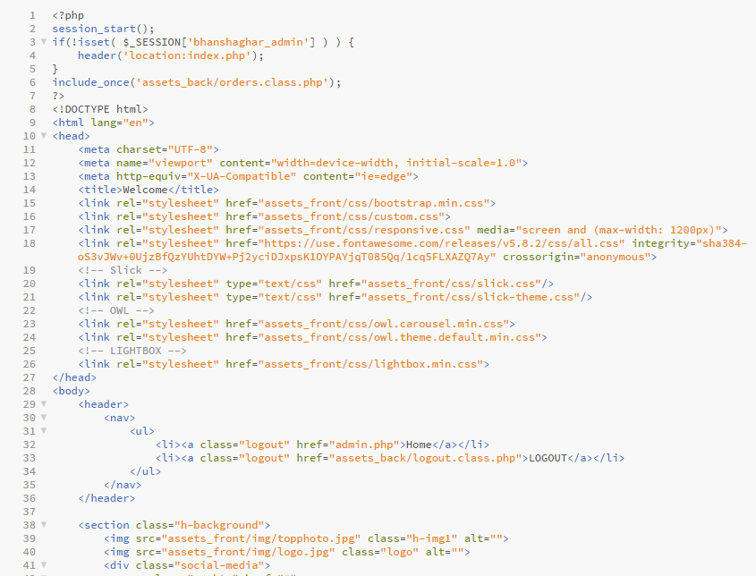

Figure 42 Order code

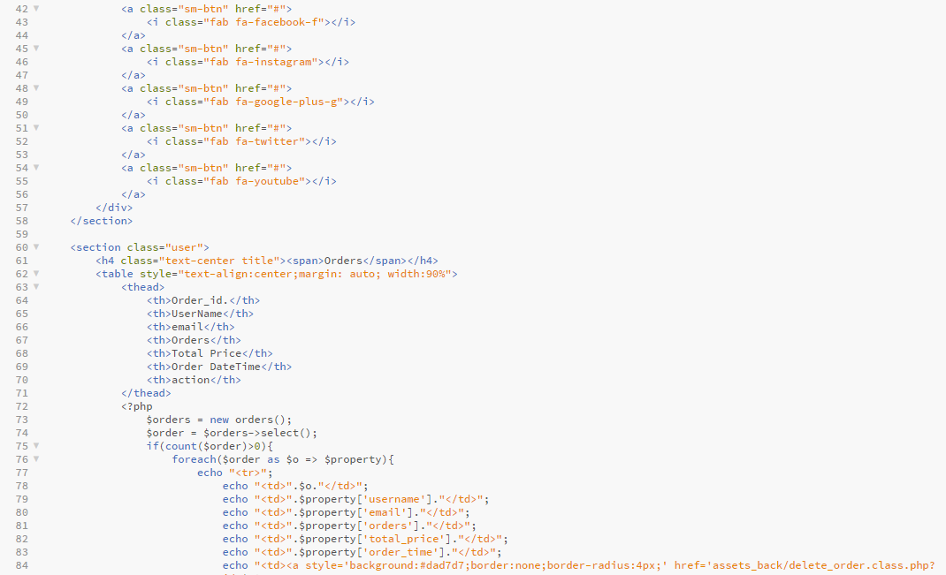

Figure 43 Order coding 2

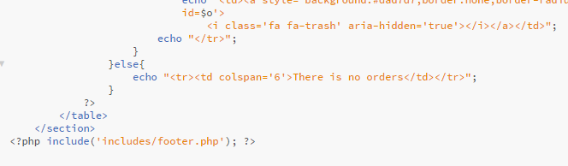

Figure 44 Ordering coding 3

Sign up

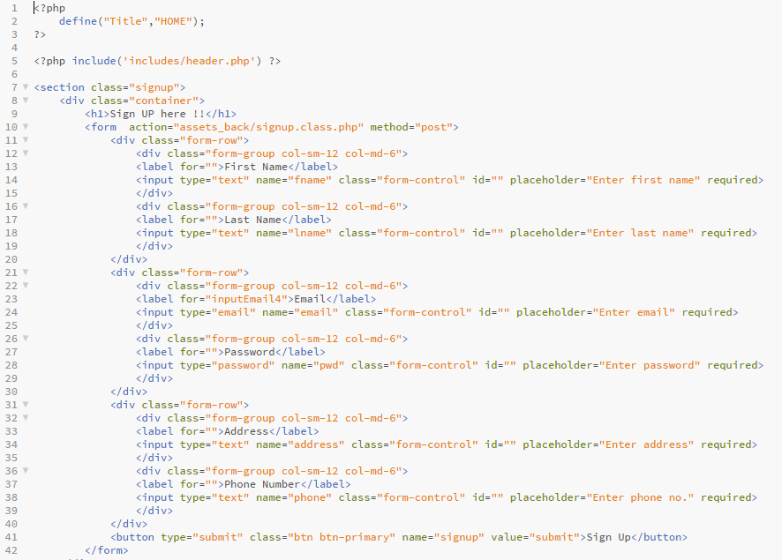

Figure 45 Sign Up code

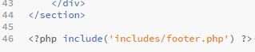

Figure 46 Sign Up Code 2

Welcome

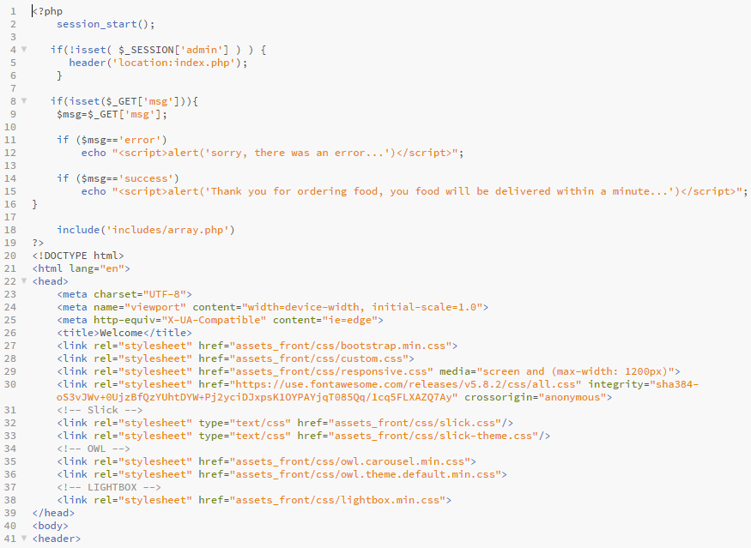

Figure 47 Welcome code

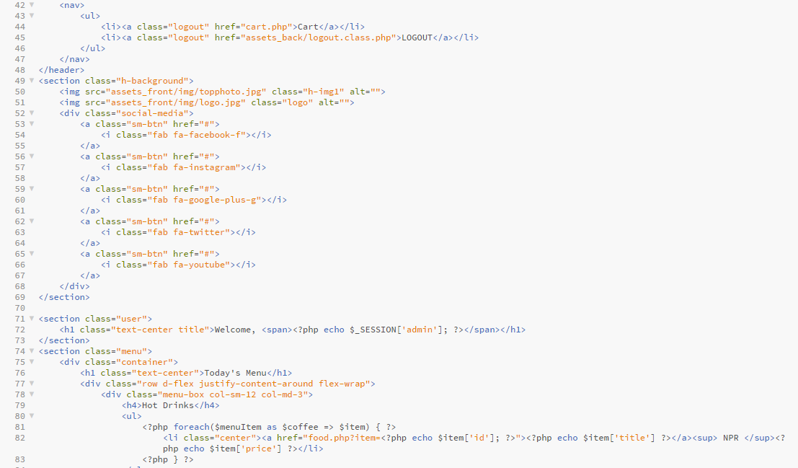

Figure 48 Welcome code 2

Add cart class

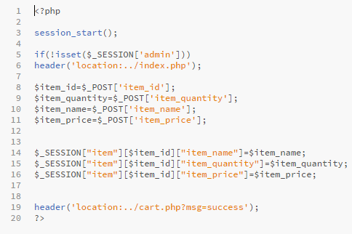

Figure 49 Add cart class code

Array class

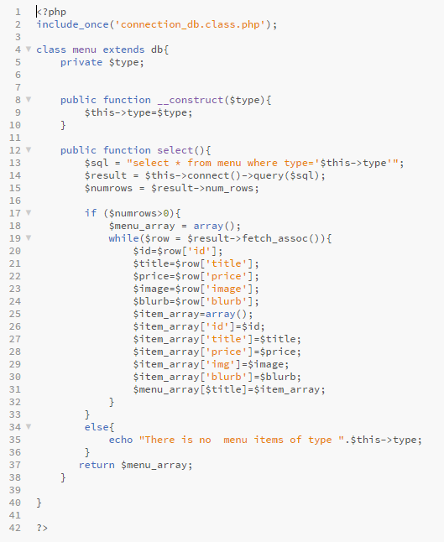

Figure 50 Array class code

Check out class

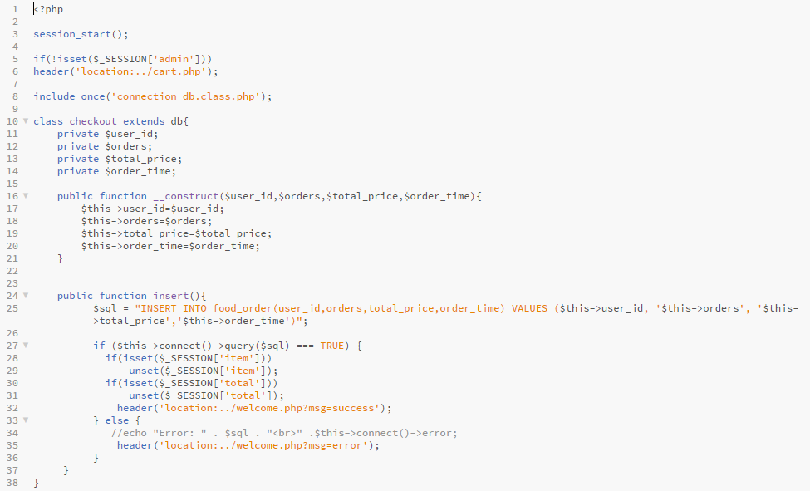

Figure 51 Check out class code

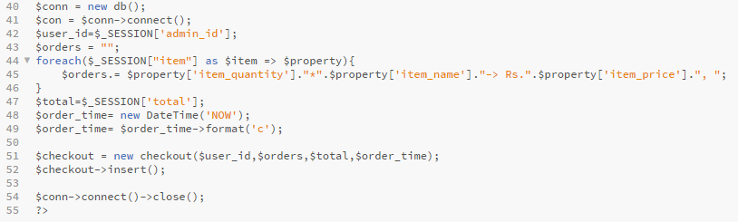

Figure 52 check out class code 2

Connection of database

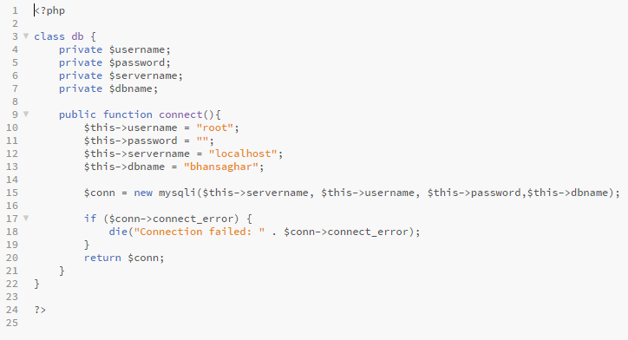

Figure 53 Connection of database

Delete order class

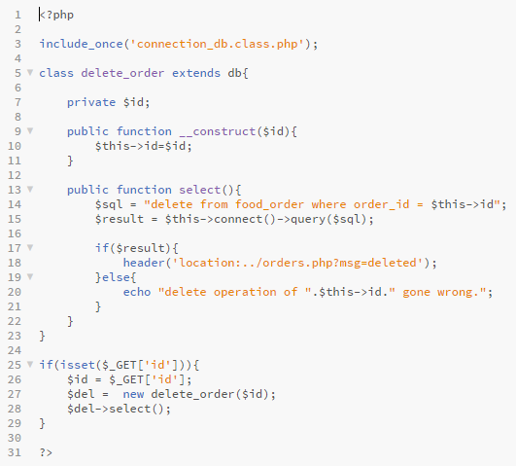

Figure 54 Delete order code

Delete user class

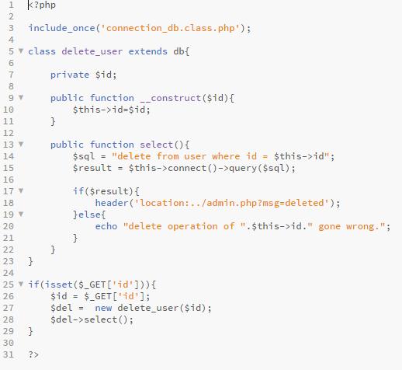

Figure 55 Delete user code

Item class

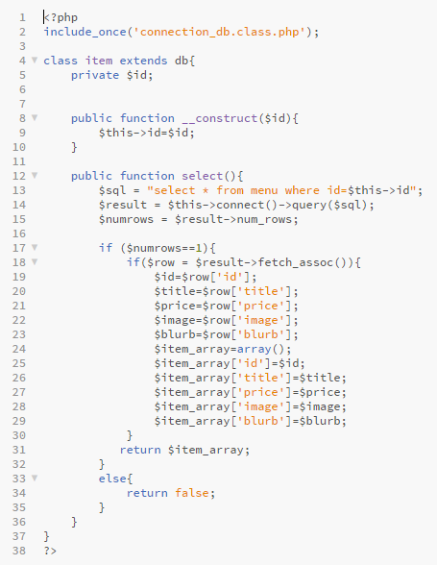

Figure 56 Item class code

Login class

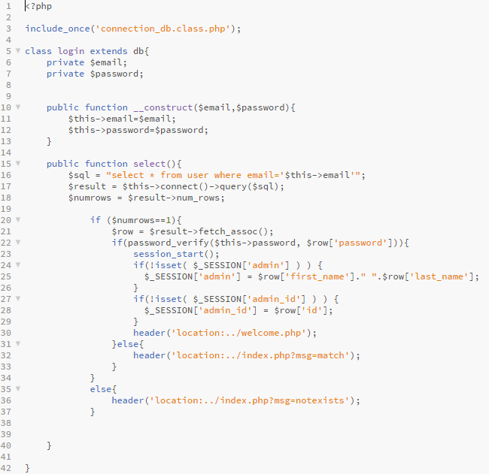

Figure 57 Login class code

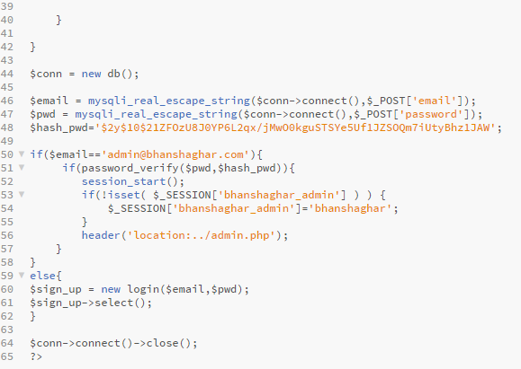

Figure 58 Login class code 2

Logout class

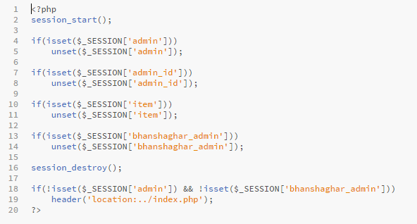

Figure 59 Logout code

Orders class

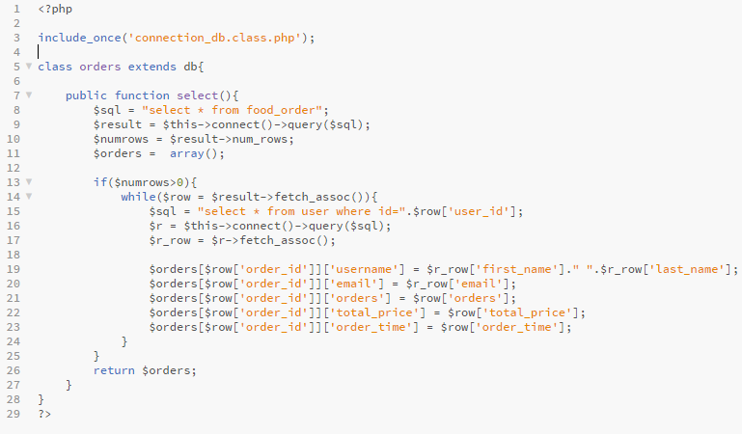

Figure 60 Order class code

Reset class

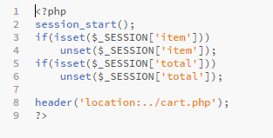

Figure 61 Reset cart class code

Sign up class

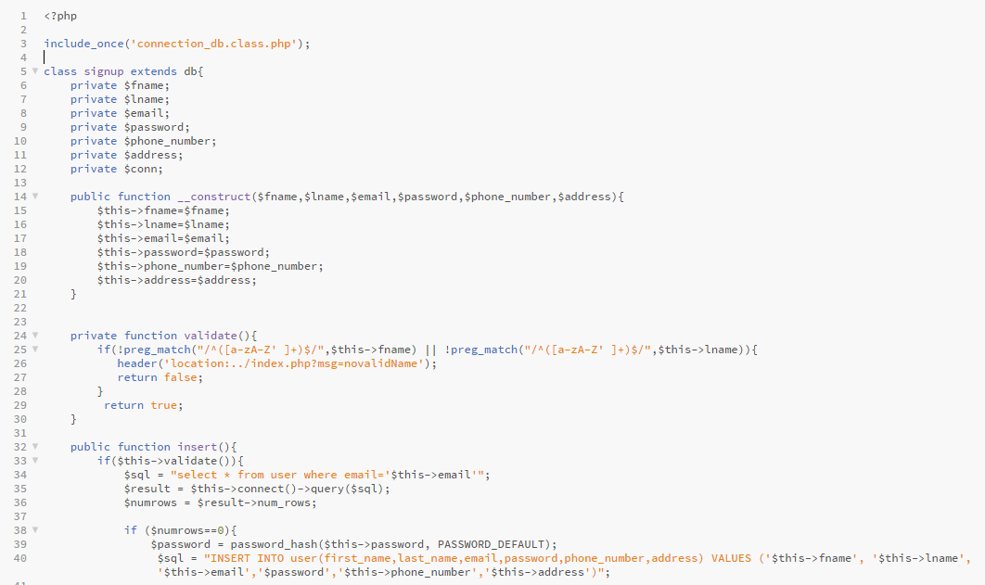

Figure 62 Sign up class code

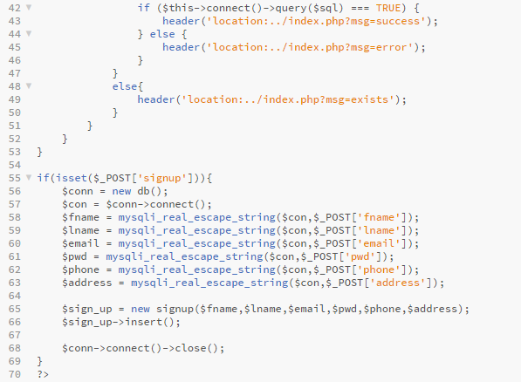

Figure 63 Sign up class code 2

User class

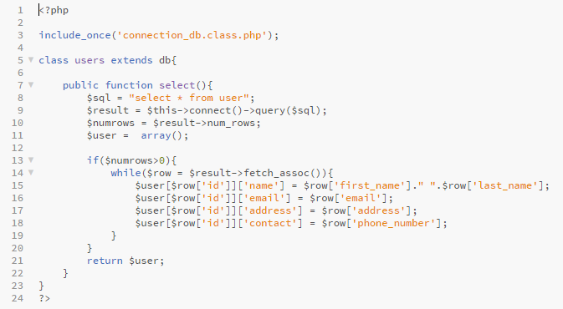

Figure 64 User class code

Array

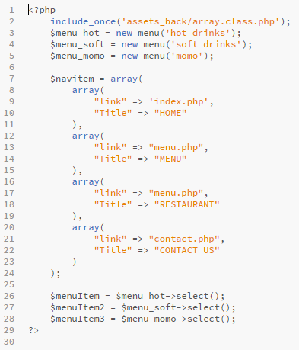

Figure 65 Array code

Footer

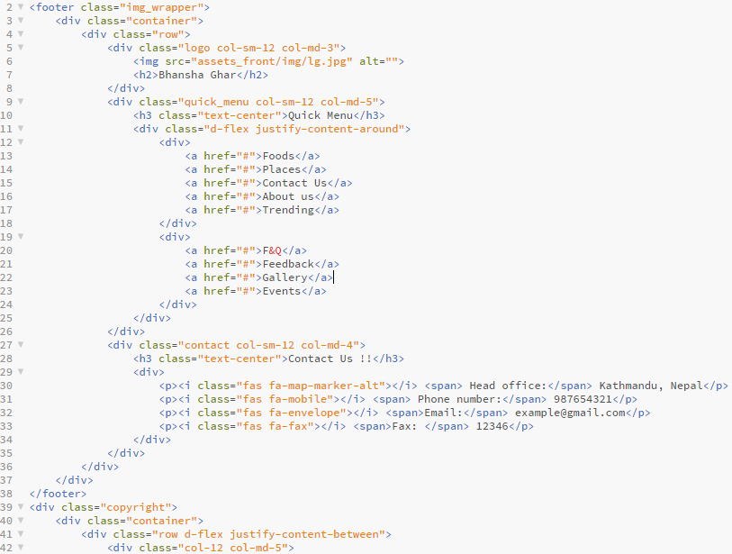

Figure 66 Footer code

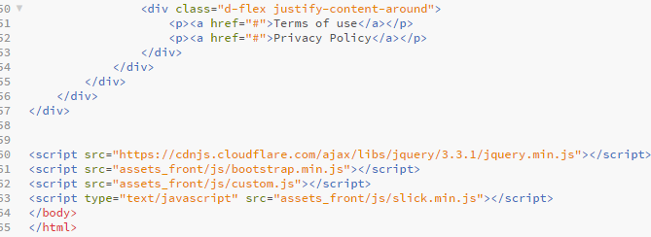

Figure 67 Footer code 2

Header

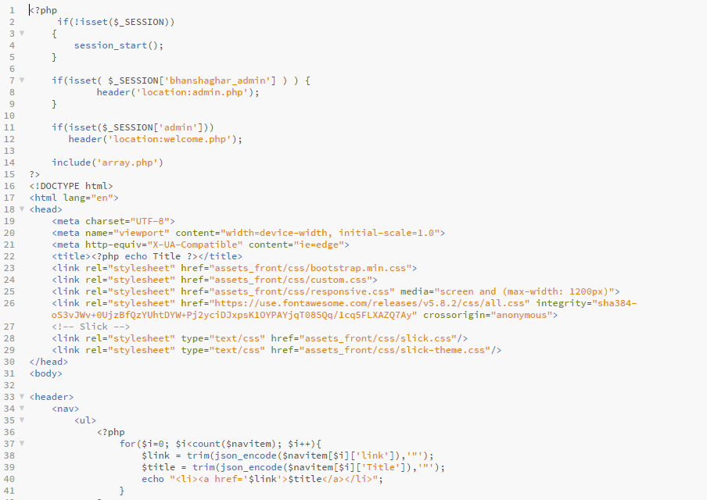

Figure 68 Header code

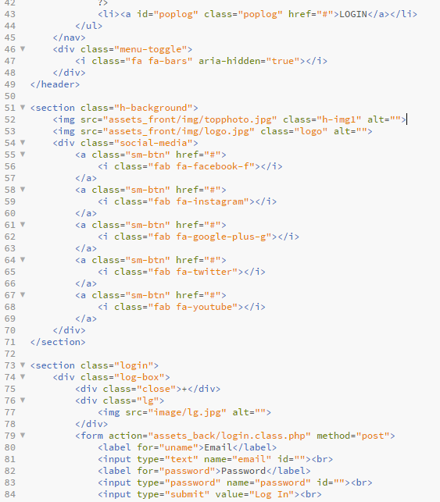

Figure 69 Header code 2

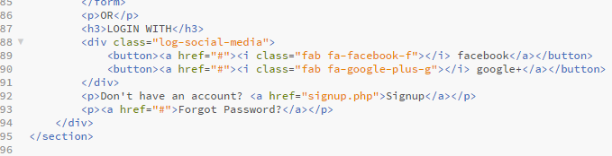

Figure 70 Header code 3

# Conclusion:

In this system, which is entitled as The Restaurant Management System has been overviewed above. The introduction, justification, problem statement, its benefits and methodology which are important to finish this project have been maintained briefly. This project wouldn’t have been completed with the help of the waterfall methodology, MVC design pattern, and to complete the project time have been divided with the help of the Gantt chart. Problems and risks which have been mention in the project have also discovered the project to get over it. Configuration Management is also done to make a better software with complete efficiency.